# Search

Problem is defined by…

state-space model = a set of discrete states

eg. driving states = towns/cities

initial state (IS) & goal state (GS)

solution is a sequence of actions leading from IS to GS

actions/operators

eg. road from one town to the other

transition model

a state that results from executing action a in state s

action/path cost

Classifying Environment

Static/Dynamic

Deterministic/Stochastic

outcome of actions is fully determined or not

Observable/Partially Observable/Unobservable

it knew initial state, current state

Discrete/Continuous

Abstracting state space from problem

Search algorithm

possible actions → expanding state → evaluate if the new state is the goal state

control strategy (how to pick next path to expand) → search space

search space (from the goal state, trace back to the start state) = trace

repeated state (failure to detect visited nodes → linear problem to exponential)

Tree Search vs Graph Search

Not distinguishable using state space (its structure)

Tree Search - do NOT remember visited nodes (guaranteed to have NO cycle)

space efficient

Graph Search - DO remember visited nodes

time efficient

Ex. traveling in a 2d grid

Tree Search $O(4^{d})$

Graph Search $O(d^{2})$ maximum go to a circle

Why is search difficult?

Start with unknown size/shape of the tree + unknown depth of goal state in the tree

Tree size can be $b^{d}$ where b = constant branching factor and d = depth of goal state

State vs Node

State = representation of physical config. State consists of nodes

Node belongs to one state (we can have many nodes that are goal state)

node has parent node, action taken from parent node, path cost, depth

## – Uninformed Search (DFS, BFS, UCS, IDS, DLS)

Def = blind search

Basic Search Schema

3 basic states = explored (past), frontier(current), unexplored (future)

initial frontier = start state

search strategy with priority_queue

FIFO (BFS)

LIFO (DFS)

g (UCS = Uniform-Cost Search = Djikstra’s) = sort by the path cost so far

f (A*)

Iterative search uses DFS

Bidirectional Search use either BFS or UCS

Q: what if better path is found to a node already on explored list? (it depends..heuristic search)

Search Strategy (pick the order of node expansion)

completeness (always find a solution if it exists)

time complexity + space complexity (measured with the following)

b = maximum branching factor

d = depth of least-cost solution

m = max depth of state space

(for USC, C* = true cost of optimal goal, $ε$ = min step cost > 0

optimality (always finds a least-cost solution?)

Goal Test

inserted into queue ⇒ when cost is non-decreasing function to depth

when removed from queue → optimal solution

guard against short and expensive solution

some Depth-Limited Search, Iterative Deepening Search, DFS

Ex, 5 bit has 2^5 states. Number of edges for undirected graph = 2^5 * 5 / 2

Tree search: # nodes = # paths = 5! = 120 (could go back)

Graph search # nodes = chose(5,0)...chose(5, 5) = 32 (not go back)

BFS

func BFS()

node ← NODE(problem)

if node == goal then return node

frontier = FIFO queue

seen

while !empty(frontier):

node = pop(frontier)

for each child S in expand(node):

if s == goal: return s

if s not in seen:

add s to reached

add s to frontier

* add and check all X’s children against goal, process next node if goal not found

goal test = when inserted

complete? yes

time = O(b^d) and same as the space

optimal? yes for non-decreasing cost function only of depth and NO otherwise

usually space costly

UCS

func UCS():

return Best-First-Search(problem, path-cost so far)

//sort by g(n) = path cost so far

goal test = when node is popped off queue

complete? yes if b is finite and step cost >= $ε$ > 0

Time/Space ~ $O(b^{d+1})$

optimal? yes for any step cost >= $ε$ > 0

expands in other of optimal path cost

when a node is expanded, shortest path to it has been found

nodes are expanded in order of increasing path cost

why step cost >= $ε$ > 0?

otherwise, an infinite regress

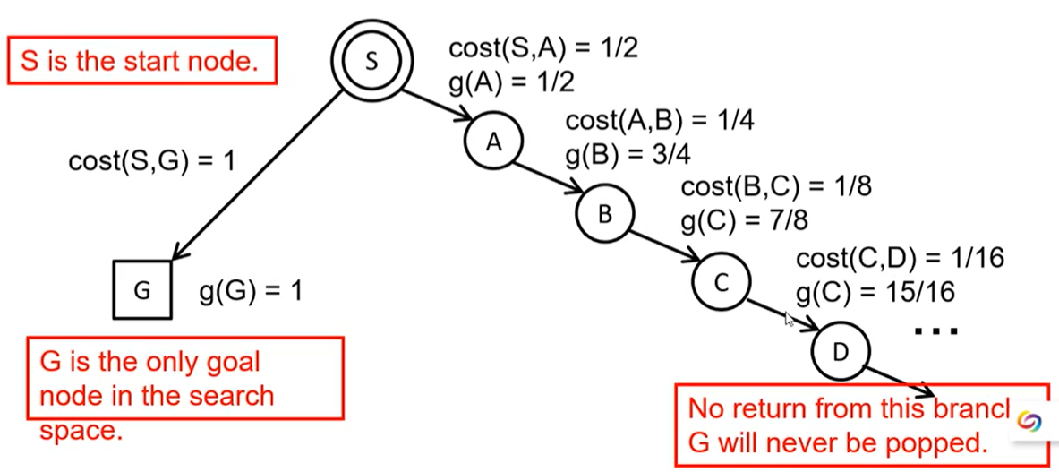

Ex. order of node expansion = S A B G, path found = SBG and cost of path = 10

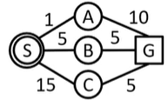

DFS

goal test = popped

complete? No ⇐ fail when searching infinite-depth spaces (graph search to detect loops)

time = $O(b^{m})$ when m = max depth of space

space = O(b*m)

optimal? No it may find a non-optimal goal first

BFS vs DFS

BFS is better for shallow goals, many long paths, many loops, small search space

always better time wise, but worse memory wise

Graph search

DFS is better for many goals, not many loops, few long paths, huge search space

always worse time wise, but better memory wise (linear space)

Tree search

IDS = DLS + iterative depth (generally the preferred uninformed search strategy)

func DLS(problem, limit)

node ← NODE(problem)

if node == goal then return node

frontier = LIFO queue (stack)

while !empty(frontier):

node = pop(frontier)

if node == goal: return node

if isCycle(node): continue

if node.depth > limit then result ← cutoff

for each child S in expand(node):

add s to frontier

func IDS(problem):

for depth = 0… inf:

result = DLS(problem, depth)

if result != cutoff return result

* when it pops, we test if it is a goal (LIFO ⇒ children order will be opposite)

DLS(depth-limited search) only search until depth L

* DFS ⇒ the children order will be opposite

if no solution found at L, increase L

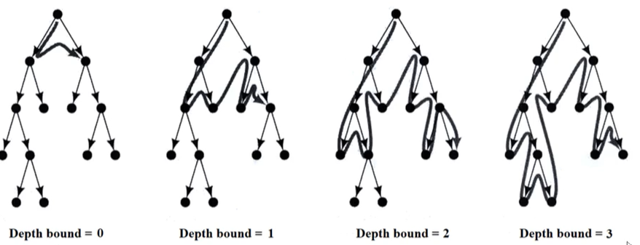

# nodes generated in a DLS = $b^{0}+b^{1}+...+b^{d-1}+b^{d}=O(b^{d})$

# nodes generated in a IDS = $(d+1)b^{0}+db^{1}+...+2b^{d-1}+1b^{d}=O(b^{d})$

DLS/IDS = b/(b-1)

complete? yes

time = $O(b^{d})$

space = O(b*d)

optimal? yes if cost is non-decreasing func of depth. No otherwise

Limitation of Uninformed Search

search space size ⇒ tedious search

## – Heuristic Search (A*, Best-First, Local)

Def = quick way to estimate how close we are to the solution

**h(n)** estimate the cost from node n to goal state (h(n) = 0 for goal nodes)

defined by **state of node n** (cost/distance to go)

**g(n)** = cost to n so far

h*(n) = true optimal cost from state of n to goal (may unknown)

g*(n) = true optimal cost from start to state of n (may unknown)

f(n) = g(n) + h(n) = estimate total cost from start node, go through node n

Best First Search

order nodes by evaluation function

greedy best first: order by h(n)

A* search order by f(n)

(BnB DFS prune by f(n) against Upper Bound)

better heuristic function ⇒ faster search

Ex. 8 puzzle

avg solution cost = 22 steps

branching factor ~3

exhaustive search to depth 22 = 3.1*10^10 states

h1 = # of misplaced tiles = 8

h2 = sum of distance of the tiles from their goal (Manhattan dist) = 3+1+2+2+2+3+3+2 = 18

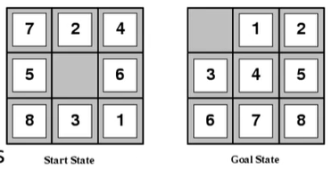

Ex. shortest path in a map

chose the children with the smallest h(n) and add its children into heap

complete?

tree version can stuck in loops (easy to prevent)

graph version is complete in finite space

incomplete in tree/graph in infinite search spaces

time & space = $O(b^{m})$

optimal? No

Compare with other search functions

Uninformed search – sort frontier by g(n)

Greedy best-first search – sort frontier by h(n)

A* search – sort frontier by f(n) = g(n) + h(n)

optimal for admissible / consistent heuristic

generally preferred heuristic search framework

mem issue can be addressed by RBFS, SMA*

Branch & Bound DFS

upper bound on solution length

upper bound can be the best solution so far

f(n) = g(n) + h(n)

prune n if f(n) >= upper bound

A* search

while uninformed search only cares the cost so far, and heuristic search only cares the cost to the goal, A* search take both into account

**Admissible** heuristic = for every node n, h(n) <= h*(n)

**h(n)** = estimate cost from n to goal

h*(n) = true cost from n to goal

**only underestimates but never overestimate the cost to get to the goal**

Theorem: if h(n) is admissible, A* Tree search is optimal

Ex. 8 puzzle h1 and h2 are both admissible (h1 is more admissible, h2 is more accurate)

Consistent heuristic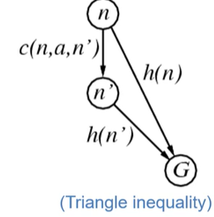

for every node, every successor n’ of n generated by any action a

c(n, a, n’) + h(n’) >= h(n)

c(n, a, n’) >= – $Δ$ h

**f(n) is non-decreasing along any path**

f(n’) = g(n’) + h(n’)

= g(n)

= c(n,a,n’) + h(n’)

>= g(n) + h(n) = f(n)

**⇒ consistency** ⇒ admissible

Theorem: if h(n) is consistent, A* Graph search is optimal

consistency ⇒ A* search expands in order of f value

complete? Yes

unless infinitely many nodes with f < f(G)

cannot happen if step-cost >= $ε$

time & space = $O(b^{m})$

space complexity is exponential, can be a problem

branching factor = # nodes for typical search node

optimal? yes if tree search is admissible and graph search is consistent

if graph search is admissible but not consistent, we need to reopen nodes

optimal efficient? yes

Mem is the major limitation of A* ⇐ IDA(Iterative Deepening A*), RBFS(recursive bfs), MA*(memory-bounded A*), SMA(simplified MA*) ⇒ less memory

Ex. admissible but not consistent

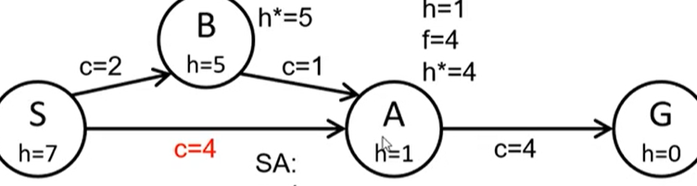

admissible ⇐ h*(S) = 3 < 7 h*(B) = 2 < 5 h*(A) = 1 <= 1

cost is the upper bound of $Δ$ h

S → B: $Δ$ h = 2 <= 2 **B→A: $Δ$ h=4 > 1 not consistent**

cost(start to end) >= – $Δ$ h = h(start) - h(end)

Why different optimality conditions for Tree and Graph?

consistency can avoid a costly scenario where we find a long cheap path after a short expensive path, and we need to update all descendants to use the new cheap path

(why dijkstra's doesn’t work with negative edges)

Ex.

removex higher-cost of identical nodes (remove left Sibiu)

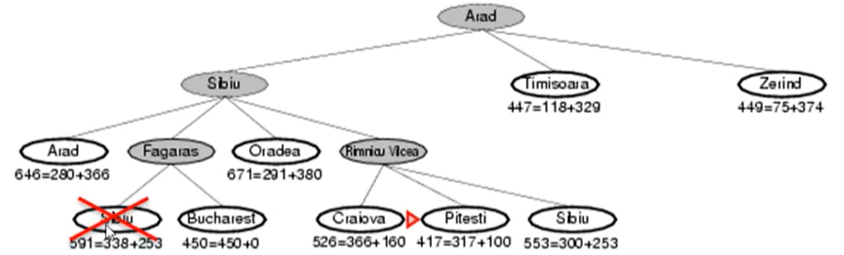

for RBFS

Properties of A* search

A* expands path along f(n) < C*, and never expands any nodes f(n) > C*

h1 and h2 are both admissible h1 < h2 ⇒ h2 is better and expands fewer nodes

Non-admissible heuristic

adjust weight of g and h

f_w = (1-w)*g + w*h

w = 0 → UCS

w = ½ → A* search

w = 1 → Greedy Best-First search

if h is admissible, f_w is also admissible for 0 <= w <= ½

Effective of Heuristic Search

Dominance = if h2 > h1 for all n then h2 dominates h1

h2 always better for search than h1

h2 expands fewer nodes than h1

Effective branching factor b*

A* generates N nodes to find a goal at depth d, b* = b of a uniform tree of depth d that contains N+1 nodes

Ex. 8-puzzle true cost = 26. avg # nodes expanded

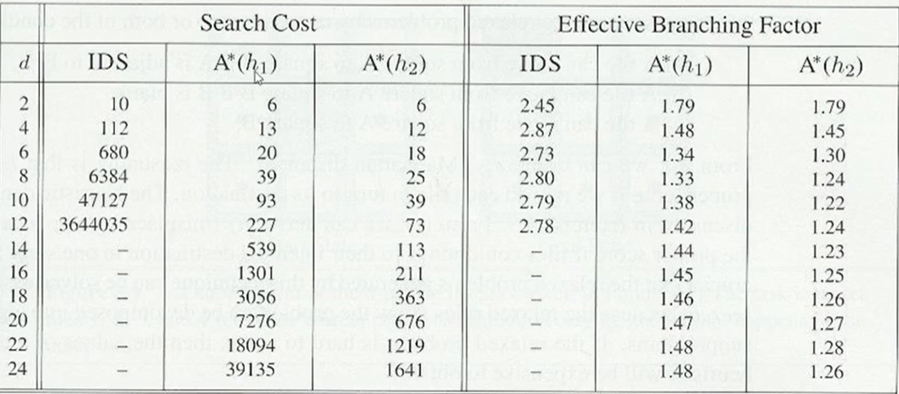

Designing Heuristic

relaxed problem = same problem with fewer restrictions

Ex. 8 puzzle original rule is a block can only move to the blank block

relaxed version1 = a block can move anywhere → h1

relaxed version2 = a block can move any adjacent blocks → h2

Theorem: heuristic generated from relaxed model are consistent

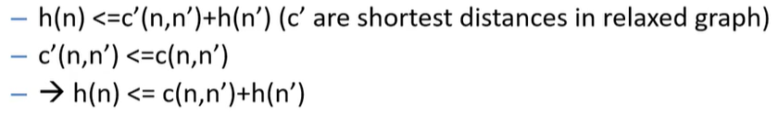

* total time of heuristic = heuristic computation + nodes expanded
* more powerful heuristic ⇒ harder to compute + more pruning power
* recognize a relaxed easy problem (so that we can solve using a greedy algorithm)
* No dominates between h1 and h2, then we use max(h1, h2)

Local Search (non-systematic)

Systematic search = enumerates all nodes in a systematic manner (bfs, dfs, ucs, A*...)

many problems the goal state = solution

local search returns good but not optimal solution

State space = set of "complete" configurations

Find a complete configuration satisfying constraints

– Examples: n-Queens, VLSI layout, airline flight schedules

configuration with best cost/value – optimization problem

Local search algorithms

Keep a single "current" state, or small set of states ⇒ mem good

Iteratively try to improve it / them

Pseudo code

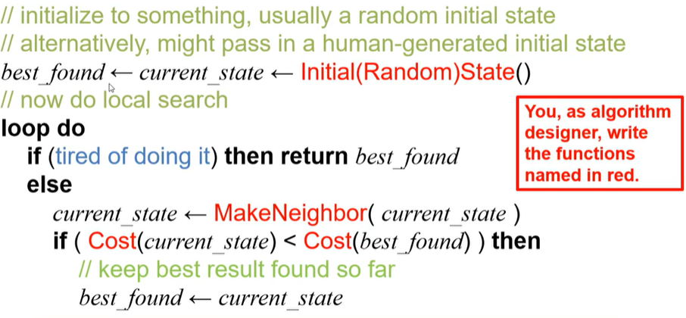

termination criteria can be iteration #, clock time…

Problem: stuck in local min/max + Ridge problem (every neighbor is worse but may be better later)

random restart when we stuck

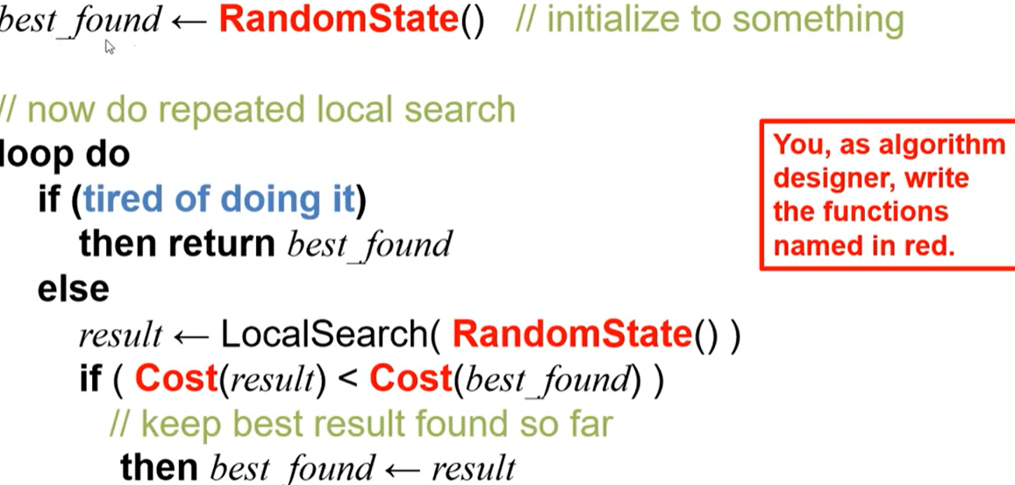

Problem: quick to get near optimal, but hard to get real optimal point

add visited state to tabu list (temporal black list with fixed length)

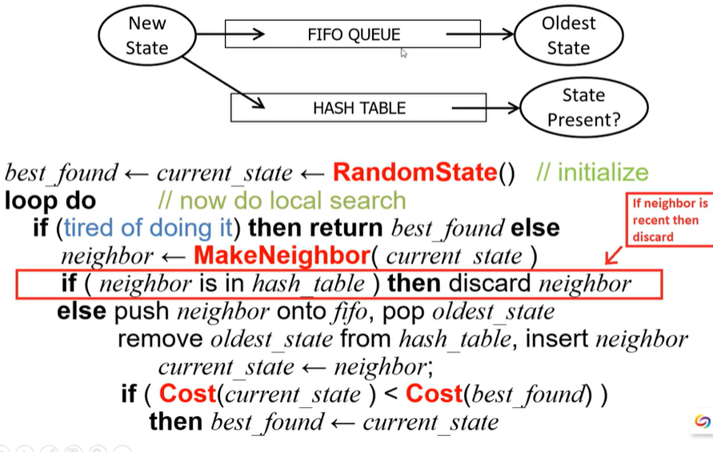

Hill-climbing search

always pick the neighbor with the highest VALUE

Ex. 8 queues

gradient descent in continuous search space

cost = J(8) where 8 = state.

derivative = positive ⇒ increasing cost

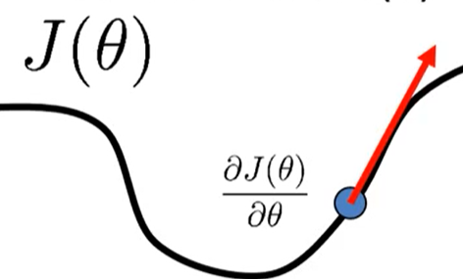

multivariable ⇒ gradient vector

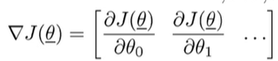

gradient = direction of steepest ascent

negative gradient = steepest descent

WalkSAT

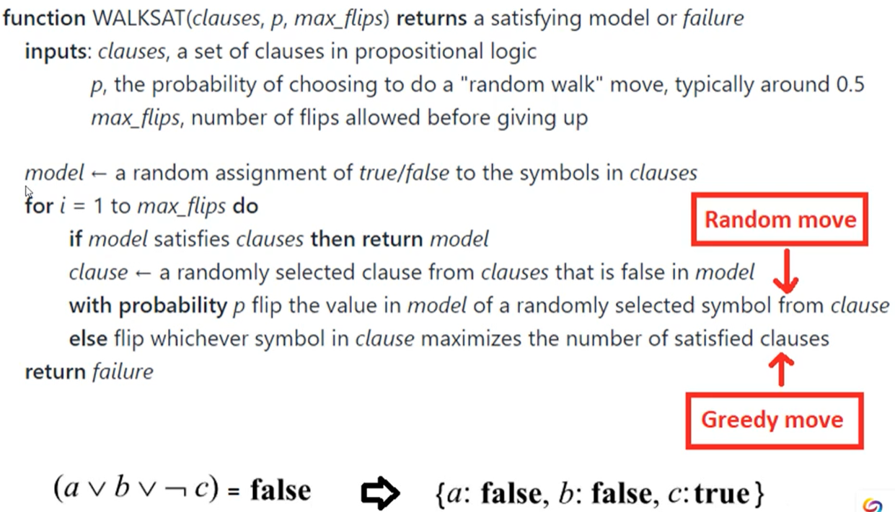

Local Beam Search

Start from k states,

if successor S is the goal, stop. Else add the best S and repeat

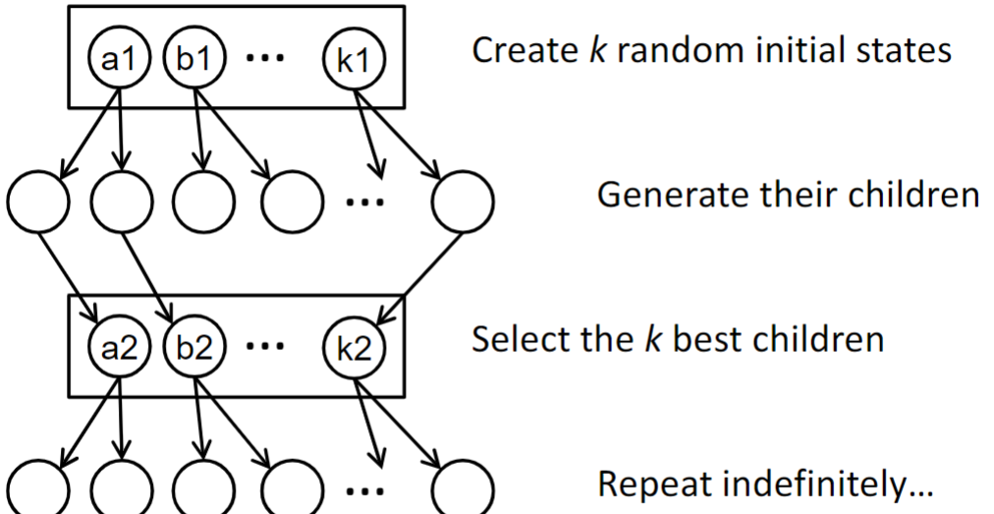

– May lose diversity as search progresses, resulting in wasted effort

Summary

Local search maintains a complete solution

– Maintains a complete solution, seeks consistent (or at least good)

– vs: Path search maintains a consistent solution; seeks complete

– Goal of both: consistent & complete solution

• Types:

– hill climbing, gradient ascent

– simulated annealing, other Monte Carlo methods

– Population methods: beam search; genetic / evolutionary algorithms

– Wrappers: random restart; tabu search

• Local search often works well on very large problems

– Abandons optimality

– Always has some answer available (best found so far)

– Often requires a very long time to achieve a good result

## – Games

Assumption

Two agents against each other “zero-sum”

fully observable environment

game theory: deterministic, turn-taking, zero-sum, perfect information…

Type of games

Non/deterministic + im/perfect information

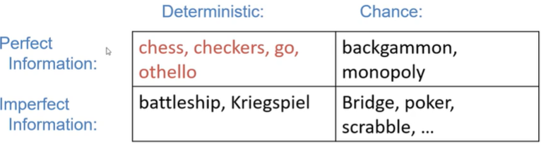

deterministic perfect information is easiest

Search vs. Game

Search - no adversary

solution = a path from start to goal

evaluation function f = estimated cost from start to goal through a given node

action has cost

Game - adversary

solution = strategy

time limit ⇒ approximate solution

evaluation function = goodness of game position

Define Game as Search

initial state

player(s) = which player has the move in state s

action(s) = action choice in state s

result(s, a) = result of a action from state s

terminal-test(s) = if game is finished in state s

utility(s) = # of terminal state s for player p (eg. +1 for win and -1 for lose)

Ex. game tree of tic-tac-toe

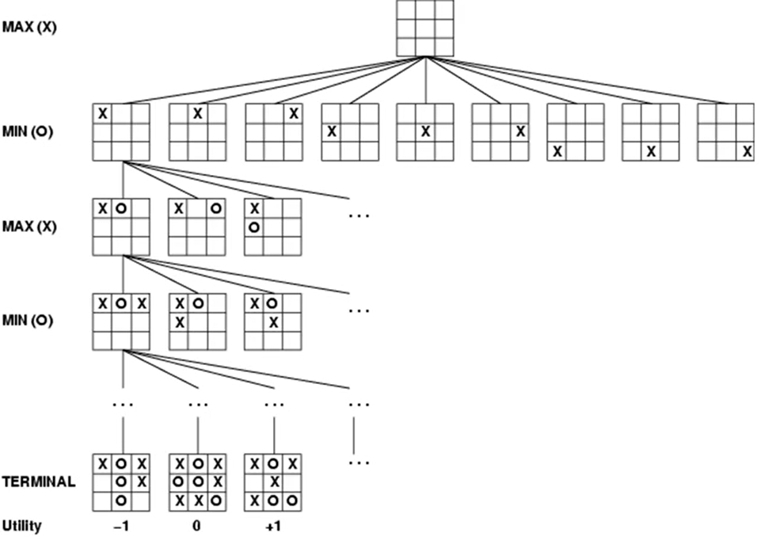

Ex. game tree of Grundy (split a number in an uneven way)

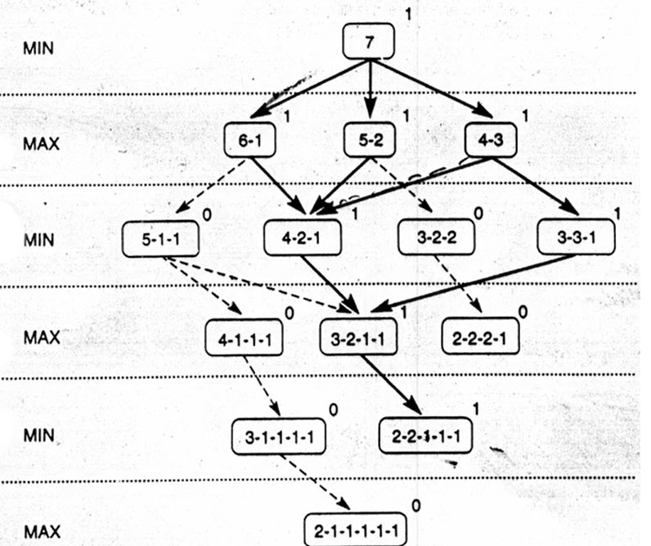

0 mean MAX player’s lose and MIN player’s win

For (5-1-1) node,

MIN player’s value = min of its children = min(0, 1) = 0

MAX player’s value = max(0,1) = 1

means MIN/MAX player can choose to win

**value doesn’t matter, we just want to know the right move**

MinMax - an optimal procedure

finds the optimal strategy or next best move for MAX

brute force to generate the whole game tree and value of the leaf nodes ⇒ backtrace

Ex.

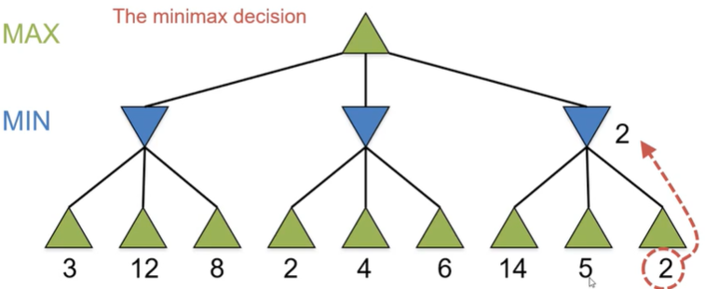

MIN level nodes has value 3 2 2

MAX root node has value 3

this approach can minimize the worst-case

Pseudocode for MAX player as the root

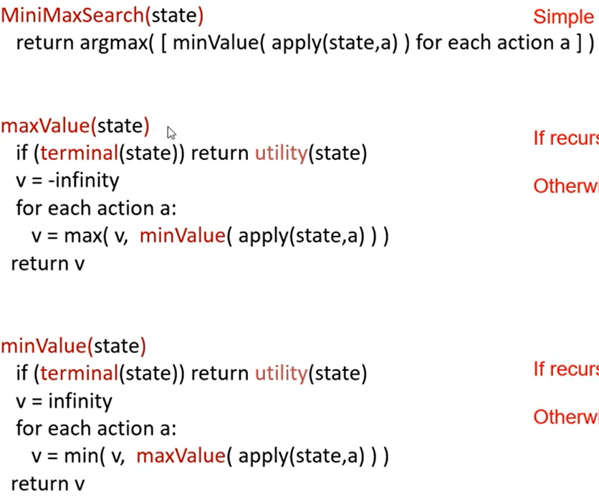

complete? yes for finite tree

optimal? yes (with or without optimal opponent)

time = $O(b^{m})$ where m = depth of the tree, b = branching factor

space = O(bm) for dfs generates all actions at once

= O(m) for backtracking generates action one at a time

Improve Game Search

Why? game tree size can grow very large ⇒ exact solution is infeasible

cutoff before game ends (certain depth) ⇒ large b will be not practical

eg. chess b^m ~ 10^6 and b=35 ⇒ m ~ 4 (4 look-ahead is a poor chess player)

H-MinMax

Static (Heuristic) Evaluation Function

def = how good the situation is for the player

(eg. X for player 1 then -X for player 2)

Ex. tic-tac-toe

static evaluation function = # of possible win lines

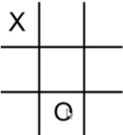

For X, it has 6 possible wins = 2 rows + 2 col + 2 dia

For O, it has 5 possible wins = 2 row + 2 col + 1 dia

Generate game tree if we look 2 steps ahead (corner, center, edge)

MAX player’s 1st move

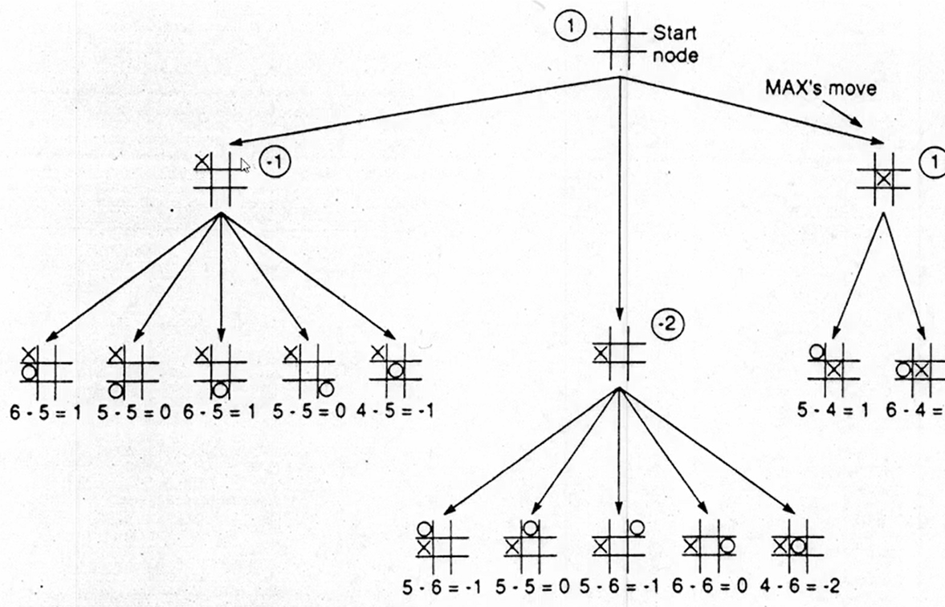

MAX player’s 2nd move

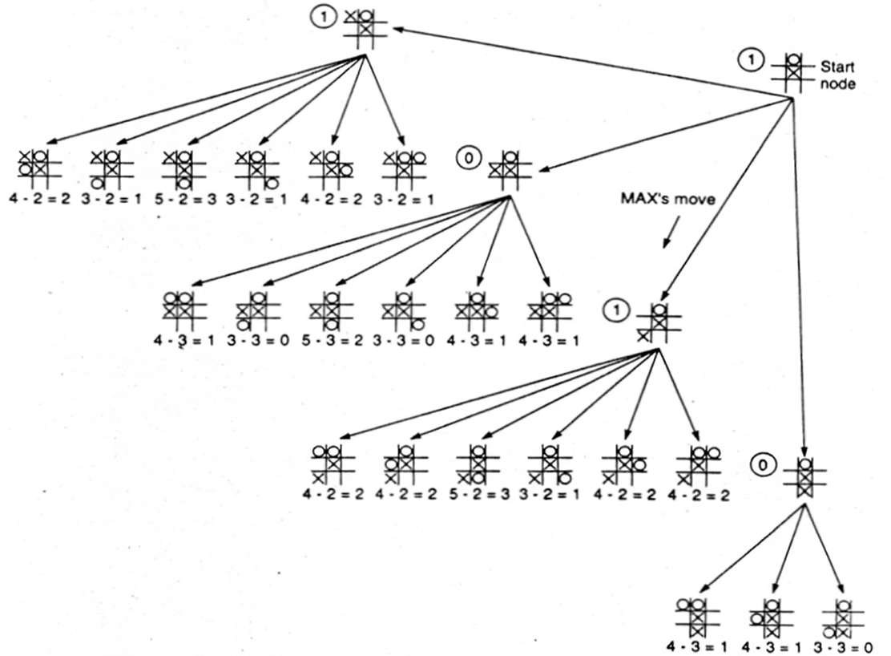

MinMax vs H-MinMax

as soon as we choose the best move, heuristic function is good

Issues

time limit of a move → iterative deepening to get the good move

horizon effect ⇒ cannot see anything deeper

continue searching on promising branches or until the battle ends

need to eliminate some redundant search

Alpha-Beta Pruning

$α$ = highest-value choice found at any choice point of path at MAX (default -inf)

update it on MAX node

$β$ = lowest-value choice found at any choice point of path at MIN player (default inf)

update it on MIN node

prune whenever $α≥β$

MAX nodes, we want bigger value in children’s min

Ex. tic-tac-toe

left node’s EVAL = -1

middle node is valuable if its min is larget than -1 (not worthy to search)

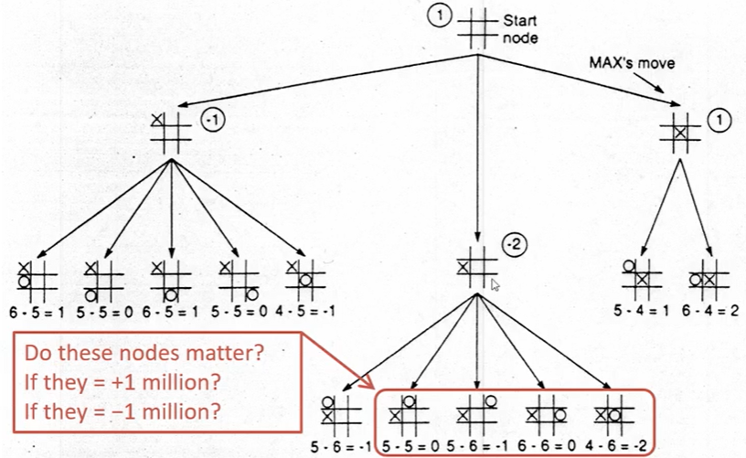

Ex.

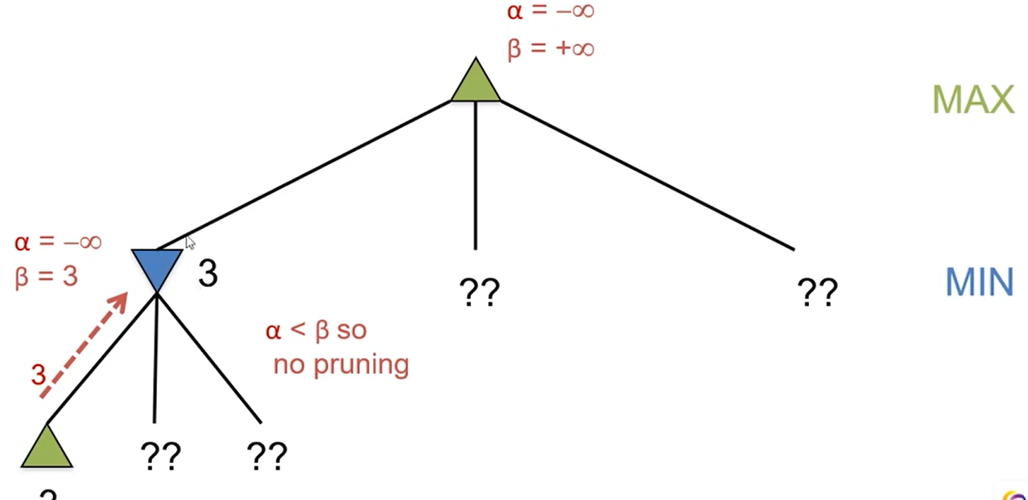

update MIN’s b = 3 from its children. Update root’s a = 3

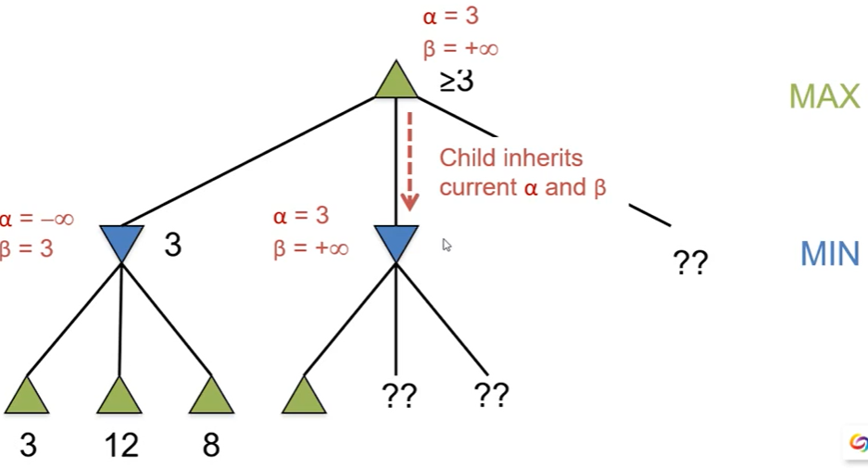

the middle MIN will inherits root’s a & b to be 3 and +inf

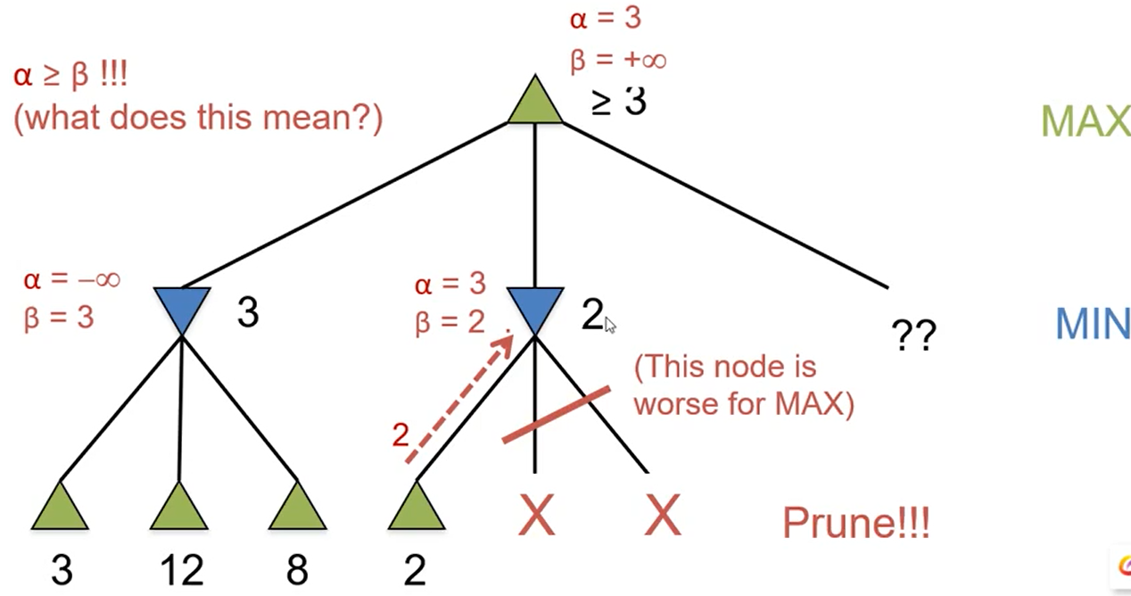

**middle MIN update b = 2 from first child ⇒ when pass to next child, we have a >= b ⇒ prune the following children of middle MIN**

Pseudocode

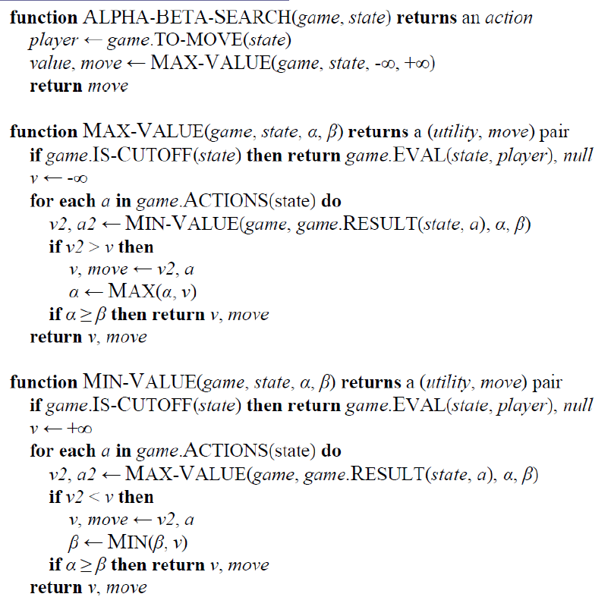

Performance

worst case = heuristic search (no pruning)

best case = always choose the left-most move

often $O(b^{d/2})$ instead of $O(b^{d})$

* alpha-beta doesn’t change the final result

Ex.

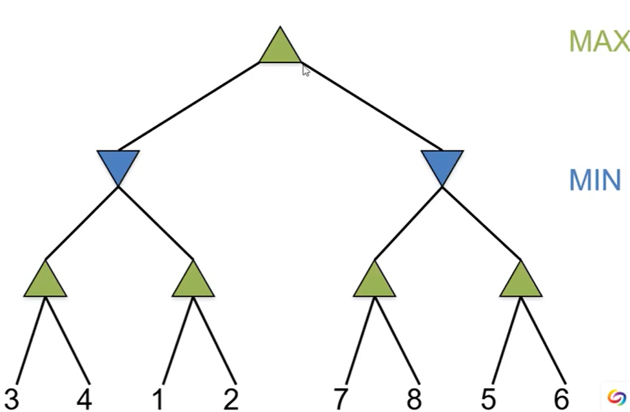

MAX

MIN

MAX a=6

+inf

MIN 6 5 8 7 2 1 3 4

No pruning ⇐ preferable nodes always appear last

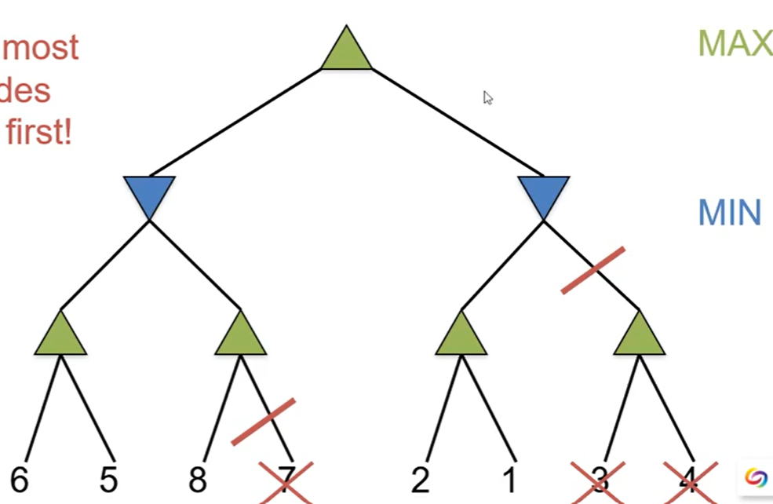

Iterative Deepening

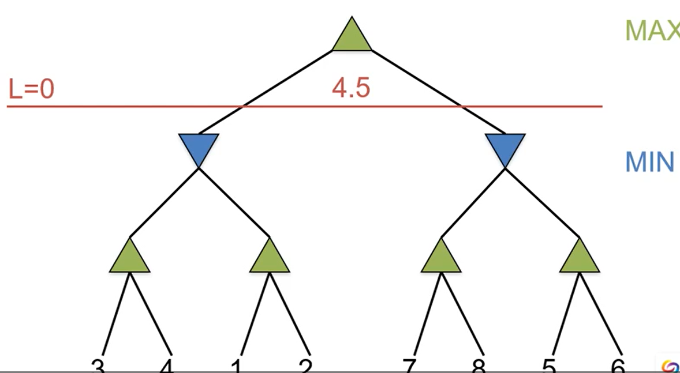

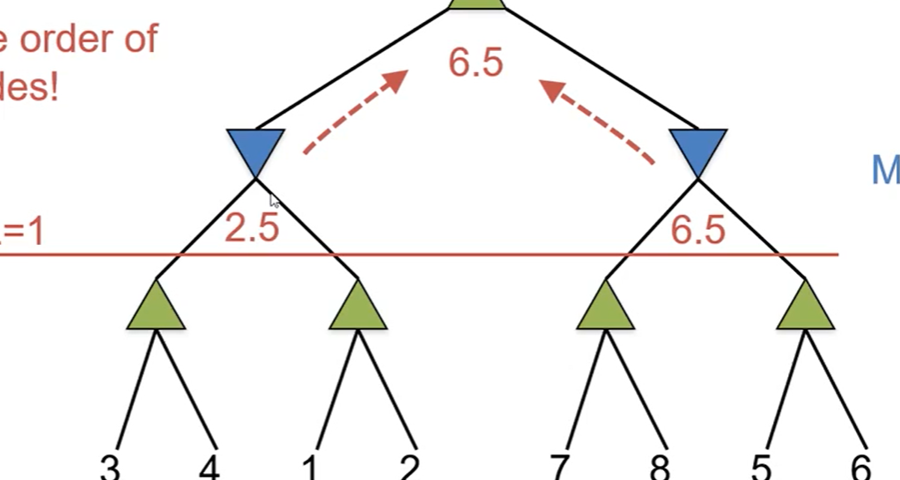

because right node is preferable, so we will switch the two blue nodes

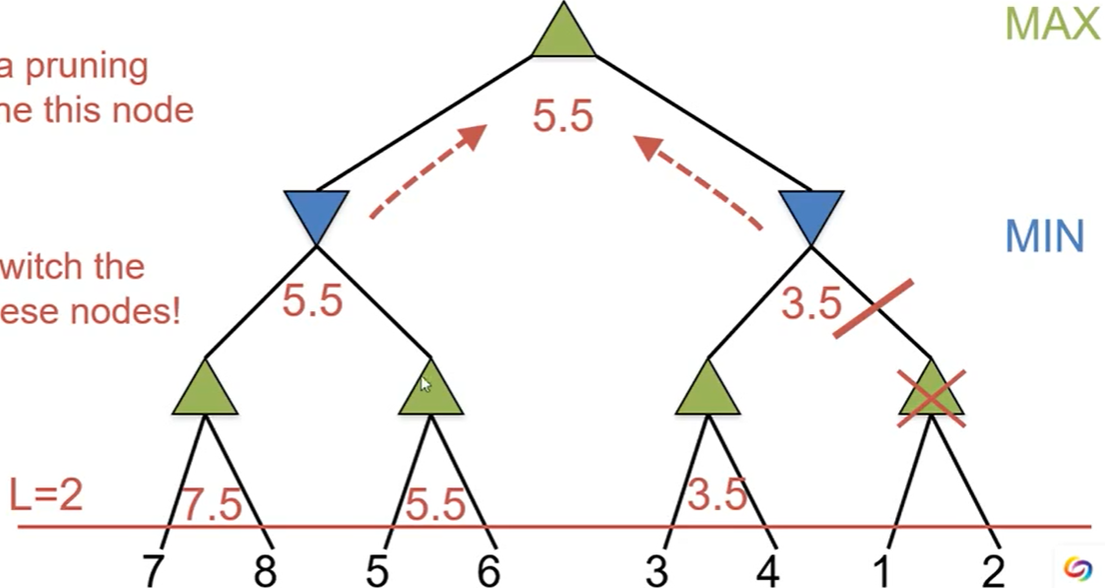

Ex.

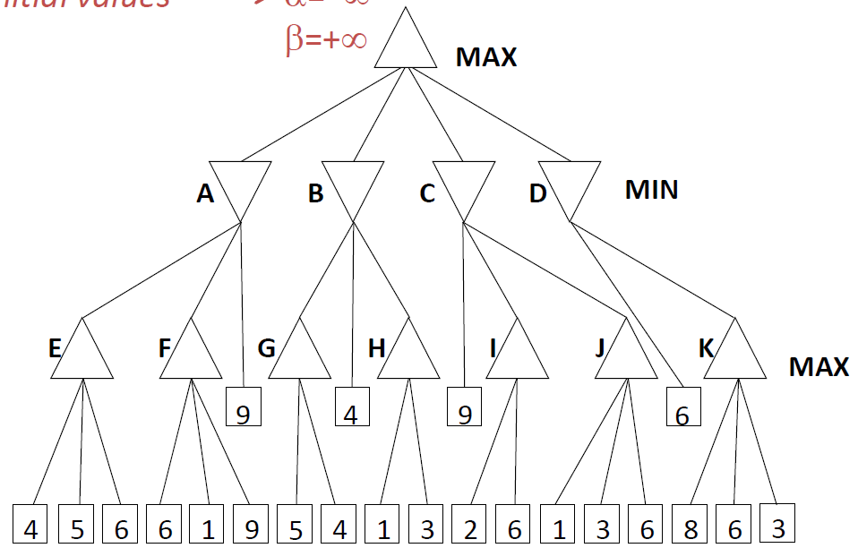

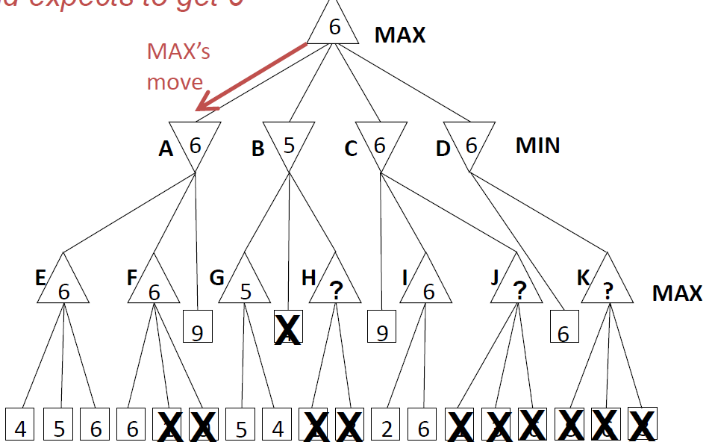

Failure

when search tree is too large ⇒ cannot reach the significant step

⇒ use ML on historical game pattern

Sampling used when hard to compute/analyze exactly

Monte Carlo Sampling

random pick moves until end → avg the result to get the best move

self-play rollout → good/bad result means every move is good/bad

compute avg win-rate over this position/move

pick the highest avg win-rate

Exploitation vs. Exploration

Exploitation = use old move with best win-rate

Exploration = try new move

Ex. multi-arm bandit with goal to minimize regret

regret = what you could have made – actual output

pick the best potential value instead of actual value

blue = potential, green = actual, red = estimated

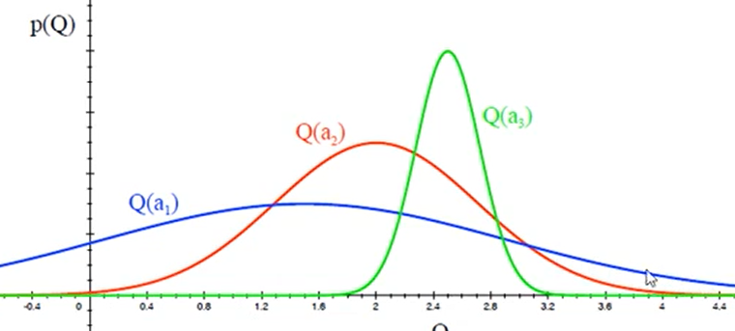

after picking the blue, we are less uncertain about the value

Upper Confidence Bound (UCB)

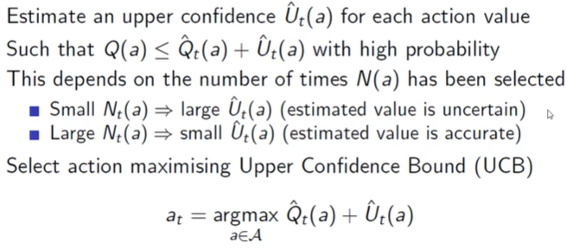

current value + bound value

Heoffding’s inequality (prob of making a mistake is no more than …)

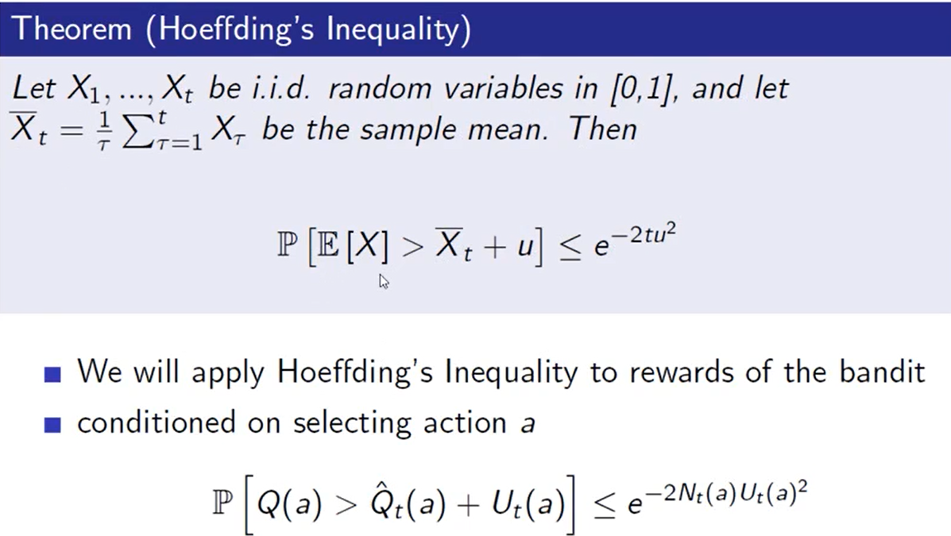

calculate UCB

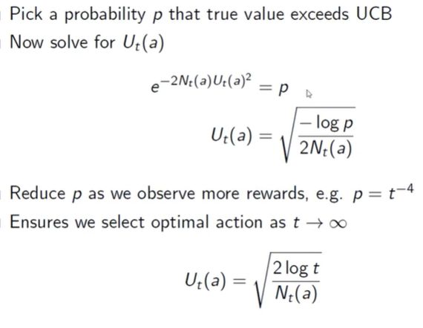

UCB gets logarithmic asymptotic total regret 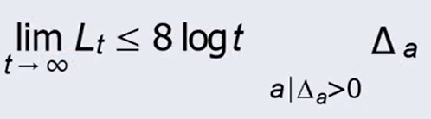

MCTS (Monte Carlo Tree Search)

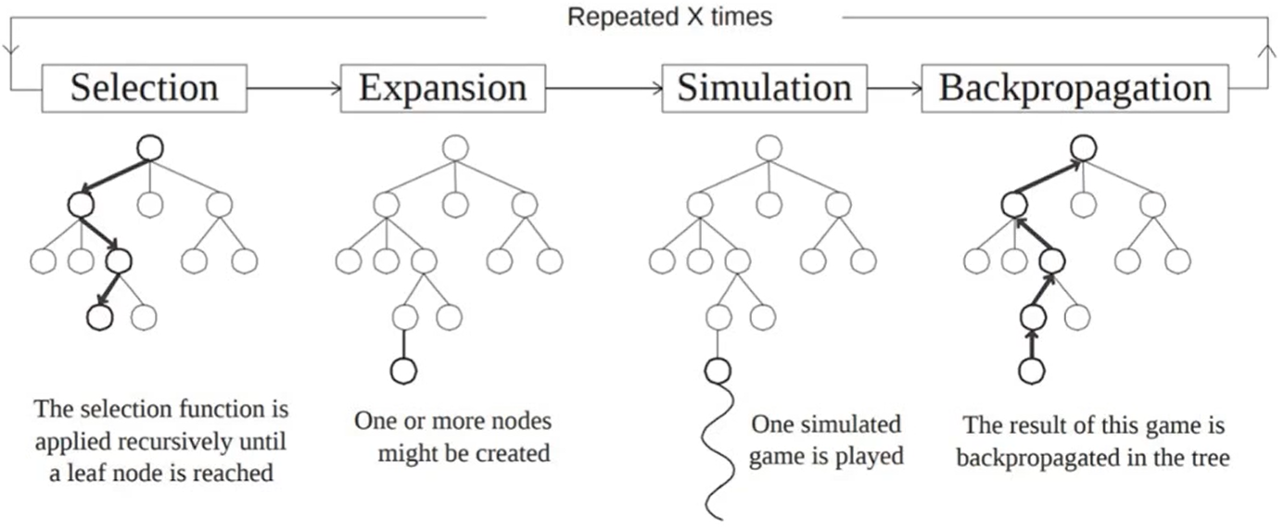

Selection (UCT - upper confidence bound for trees)

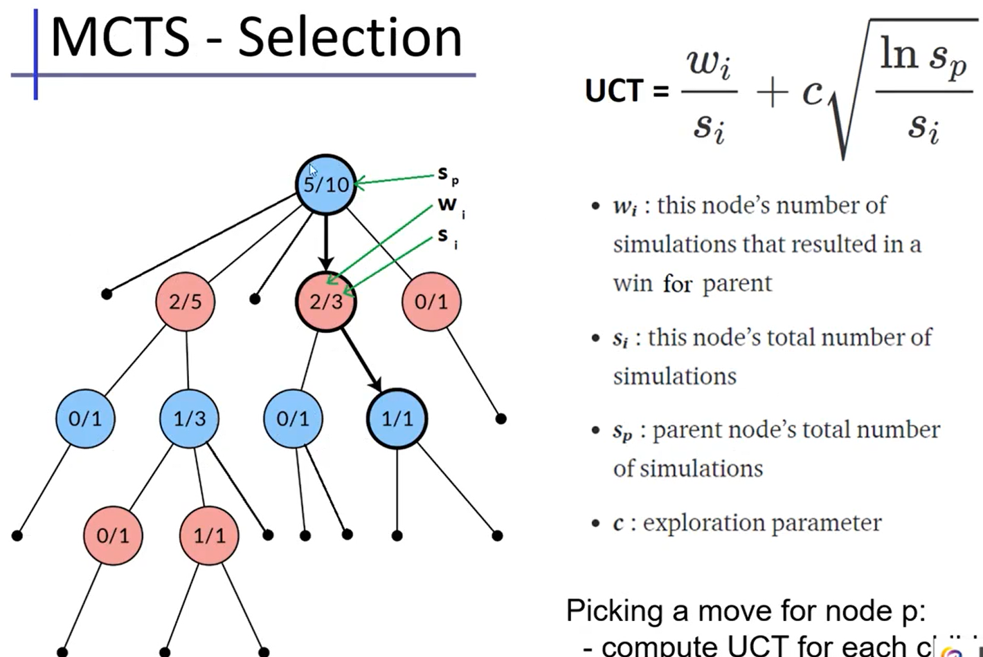

Ex. back-propagate

add 1 to s_i of all antecedents

add 1 to w_i if its parent wins

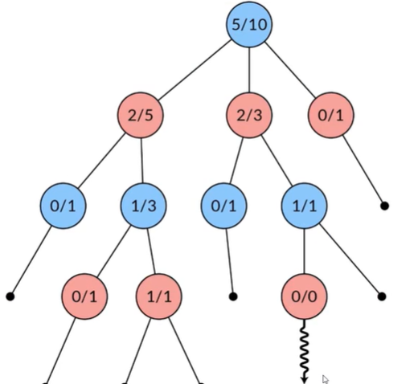

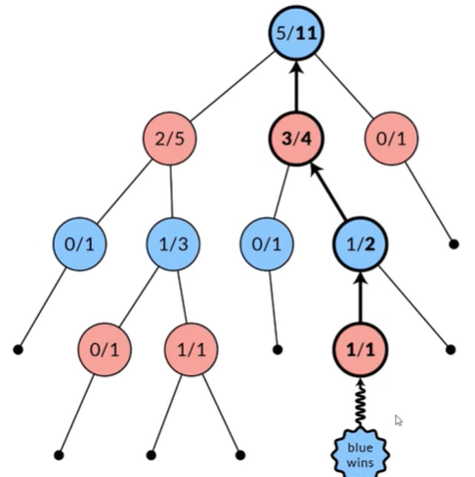

every time, we expand the tree by 1 node

pick the best move with highest wi/si (win-rate)

Muti-Player Game

Non-deterministic Game

Partially observable game

# Knowledge Representation

## – Constraint Satisfaction Problems

variables

discrete

finite domains, size of d ⇒ $O(d^{n})$ complete assignment

infinite domains → infinite solutions

continuous usually linear constraint

state = assignment of values to variables.

complete/partial = all/not all variables are assigned

consistent = not violating constraints

solution = complete + consistent assignment (satisfy all constraints)

constraint

unary involves a single variable (Ex. SA != green)

binary involves at most 2 variables (Ex. SA != WA)

higher-order involves 3 or more variables (ex. Job A, B, C all running at the same time)

can be expressed with multiple binary constraints

ex. Simple example: 3 variables X,Y,Z

Domains Dx={1,2,3}, Dy={1,2,3}, Dz ={1,2,3}

Constraint C[X,Y,Z] = {X+Y=Z} = {(1,1,2),(1,2,3),(2,1,3)}

(Plus other variables & constraints elsewhere in the CSP)

Create a new variable W, taking values as triples (3 tuples)

Domain of W is Dw ={(1,1,2),(1,2,3),(2,1,3)

Dw is exactly the tuples that satisfy the higher order constraint

Create three new constraints:

C[X,W] = { [1,(1,1,2)], [1,(1,2,3)], [2,(2,1,3) }

C[Y,W] = { [1,(1,1,2)], [2,(1,2,3)], [1,(2,1,3) }

C[Z,W] = { [2,(1,1,2)], [3,(1,2,3)], [3,(2,1,3) }

Other constraints elsewhere involving X,Y,Z are unaffected

preference (soft constraint) (ex. red is better than green)

hard constraint → satisfaction problem

soft constraint = preference can choose among solutions → optimization problem

Ex. Sudoku

variables A1 to I9

domain Di = {1…9}

constraint: each row/column/block are different ⇒ 27 constraints

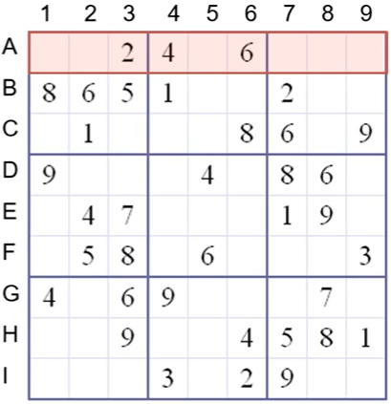

Constraint Network

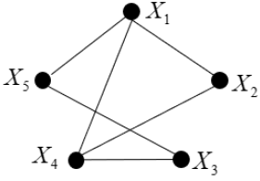

variable X1…Xn

domains of discrete values D1…Dn

binary constraints R_ij = list of allowed pairs of values. subset of D_i * D_j

solution = assignment of all variables from their domain + not violating constraints

a network of constraints represents relation of all solutions



Ex. Cryptarithmetic problems

SEND + MORE = MONEY

D + E = Y + 10a

a + N + R = E + 10b

b + E + O = N + 10c

c + S + M = O + 10d

d = M

9891 + 1098 = 10989 can satisfy

search vs. inference (soft version)

Search

In the space of partial variable value assignments

Key idea : conditioning

Inference

Derive new information implied by values/constraints

Key idea : local consistency

CSP as a standard search problem

A CSP can easily be expressed as a standard search problem.

Incremental formulation

Initial State : the empty assignment

Actions: assign a value without violating constraints

Goal test: complete assignment (by construction it is consistent)

Path cost : constant cost for every step

BUT

solution is at depth n (# variables),

BFS branching factor n*d at root → (n-1)*d on next level ⇒ $n!d^{n}$ leaves

Aside: can also use complete state formulation

Local search techniques (Chapter 4) tend to work well

Commutativity

CPS’s output doesn’t depend on the order we assign variables (start point doesn’t matter)

search space

pick a variable to expand during the search (if it violates the constraint, backtrack)

Definition: given an ordering of the variables

State = assignment to a subset of variables that is consistent.

Operators = assigning values without violation

How to choose next variable? How to pick a value from the remaining values?

Goal state = a consistent + complete

backtrack search

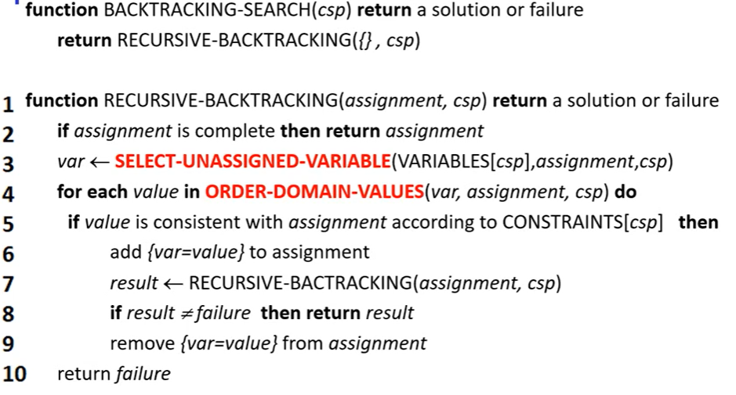

not efficient

O(exp(n))

Before search – reduce search space

During search – look-ahead and look-back can help

Look-Ahead

choose variable that will detect failure early

choose a value less likely to yield to a dead-end

MRV (minimum remaining values) or MCV (most constrained values)

a heuristic to pick next **variable** with fewest legal values (easy to detect failure)

→ reduce the branching factor

LCV (least constraining value) to pick a **value** for a variable

the one that rules out the fewest values in the remaining variables

ex. pick red because it allows more values for SA

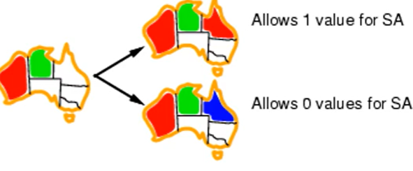

Ex. picking red on WA → NT and SA are the MRV

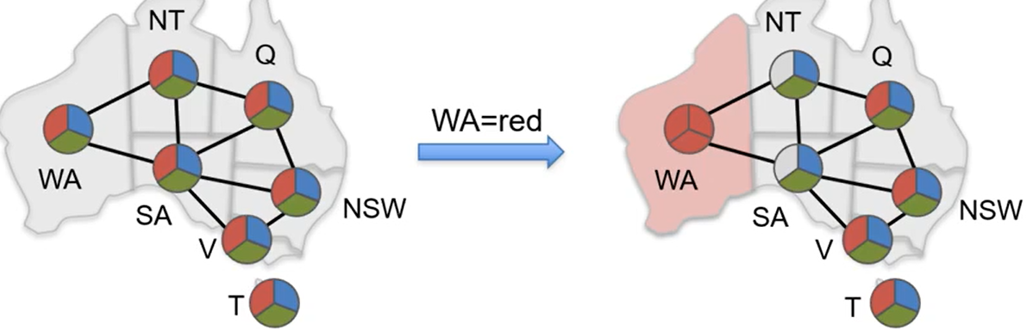

pick NT randomly → blue and green are both LCV → pick green randomly

SA becomes MCV → assign blue because it’s the only possible value

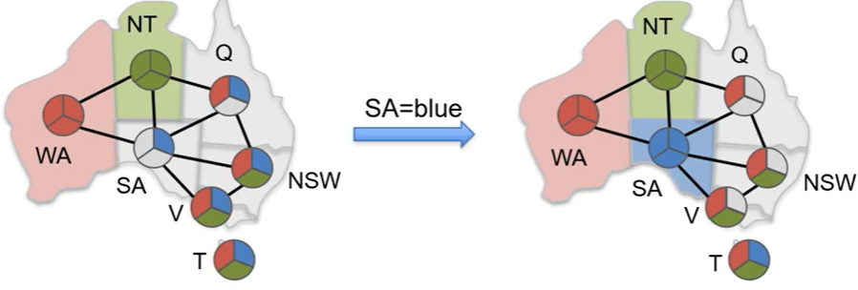

Q becomes MCS and assign red →…

Ex. same problem using degree heuristic. We will start from SA because degree(SA) = 5

Remove edges after assignment

→ select NT or Q or NSW

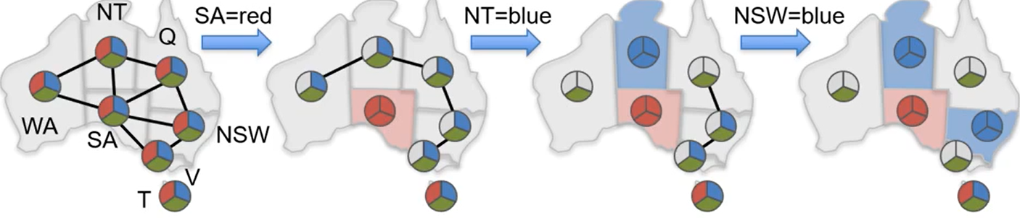

MRV + degree will have the same expansion in this problem

Inference

Derive new information implied by values/constraints

Key idea : local consistency

Ex. 4 queens problem

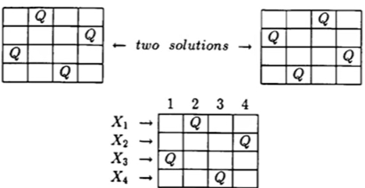

R12 cannot be (1,2) because it violates diagonal rule

M represents the possible values after removing the values that doesn’t lead to a solution

Look-Ahead - remove values that will lead to inconsistency with other domains

forward checking - checks the unassigned neighbors in constraint graph

keep track of legal values of all variables

ONLY check neighbor of the most recently assigned variable

backtrack if neighbor has NO legal values

arc consistency - check consistency among all other neighbors

Di = a doesn’t have any value in Dj to make it consistent → remove a

O(k^2)

X → Y is consistent if for every value x of X there exist some value in Y

put all arc x→y on a queue

pop one arc and remove inconsistent value from x

any change in X, push all arcs Z→X back on queue

continue until queue is empty (X can be pushed d times where d = # domain values)

complexity = $O(n^{2}d^{2})$ at most n^2 arcs and at most d^2 check time / arc

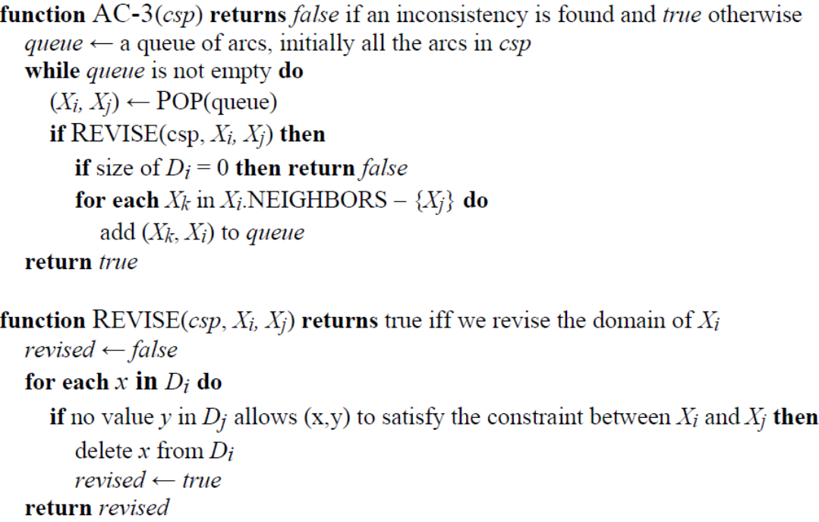

* can be run before or after assignment
* AC run until no inconsistency remains. NOT guarantee to have a solution
* more time checking but less time searching

k-consistency CSP

if for any set of k-1 variables and for any consistent assignment to those variables, a consistent value can always be assigned to any kth variable.

– E.g. 1-consistency = node-consistency

– E.g. 2-consistency = arc-consistency

– E.g. 3-consistency = path-consistency

high k ⇒ tiger network ⇒ smaller search space but more time checking (usually 2 and sometimes 3)

Look-back

Ex. (X1=r,x2=b,x3=b,x4=b,x5=g,x6=r,x7={r,b})

• (r,b,b,b,g,r) conflict set of x7

– Conflict set = a partial assignment that cannot be extended to the next variable

• (r,-,b,b,g,-) c.s. of x7

• (r,-,b,-,-,-,-) **minimal conflict-set**

• (r,-,-,-,-,-,-) **minimal no-good**

• Leaf **deadend: (r,b,b,b,g,r)**

– No-good : a partial assignment that cannot be extended to a

solution

– No-good = internal deadend

• Every conflict-set is a no-good

– But not other way around (x1=r is a no-good)

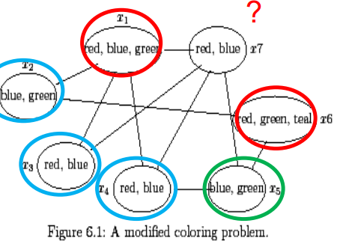

Ex. forward checking - map coloring



WA red → NT and SA have 2 legal values (blue and green)

pick Q as blue → NT and SA have 1 legal value (blue) + NSW has two

pick B as blue → SA has no legal value → backtrack

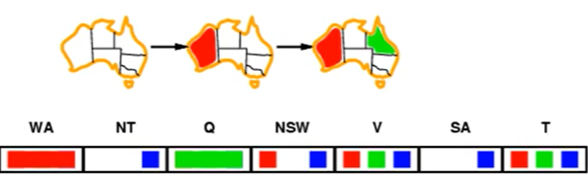

SA →NSW: okay if NSW is red

NSW → SA: consistent if NSW = red → remove blue from NSW

V → NSW: remove red from NSW

SA → NT: not consistent (detect failure earlier than FC)

Ex. forward checking - 4 queens

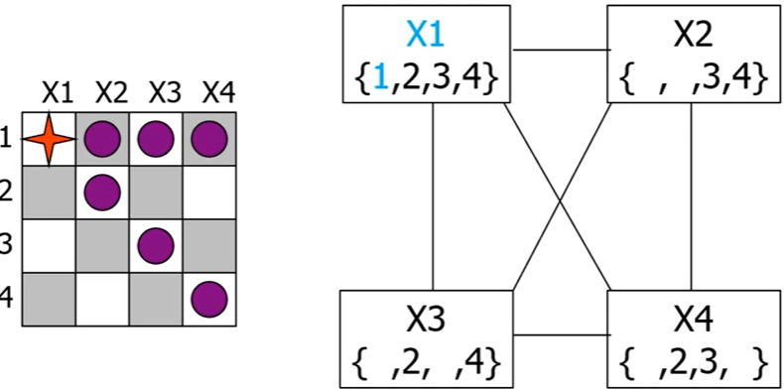

purple means removed values.

assign 1 to X1 + 3 to X2 → X3 becomes empty → backtrack and remove 3 from X2

→ assign 4 to X2 → X3 = {2}, X4 = {3} → assign 2 to X3 → empty X4 → backtrack to remove 2 from X3

→ empty X3 → backtrack and remove 4 from X2

→ empty X2 → backtrack and remove 1 from X1

Ex. arc consistency - sudoku

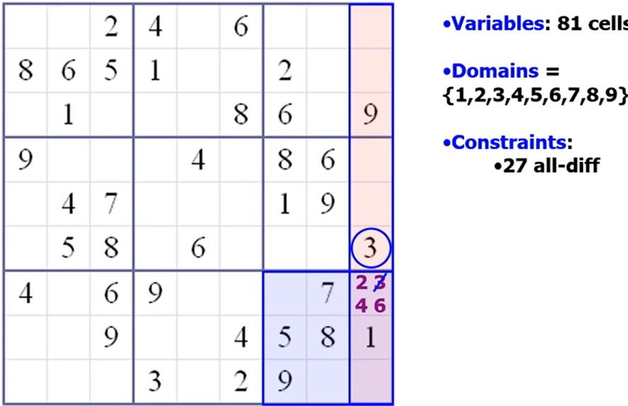

candidate value from block → check against row and column values

Ex. arc-consistency - 4 variable

1 <= X, Y, Z, T <= 3 where X < Y, Y = Z, T < Z, X < T

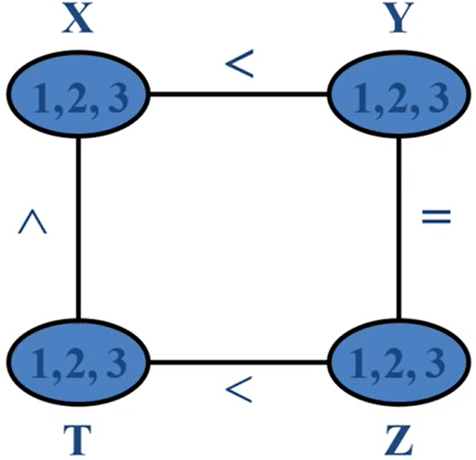

X cannot be 3. Y cannot be 1. Z cannot be 1. T cannot 1 or 3

Local Search (min-conflict heuristic)

use complete-state representation (start with complete state)

allows unsatisfied constraints

reassign variable values (ex. hill-climb in n-queen)

variable selection - random selection on conflicted variables

value selection to reduce # conflicts

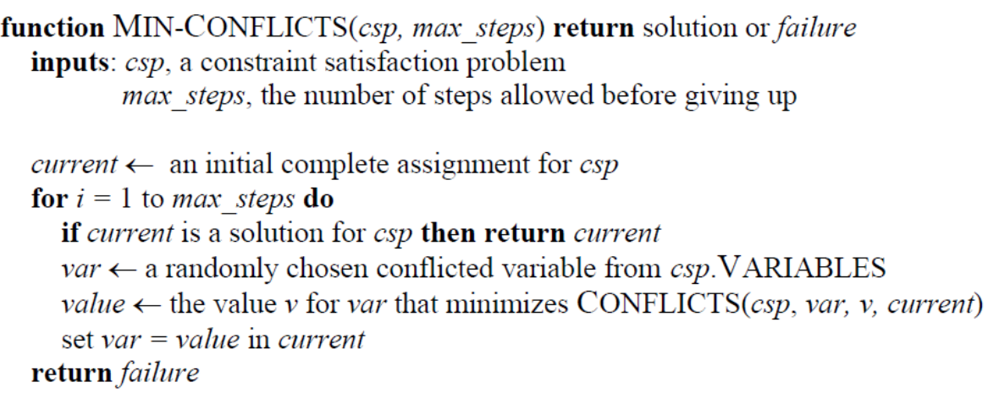

Ex. 4 queen starts with 5 conflicts

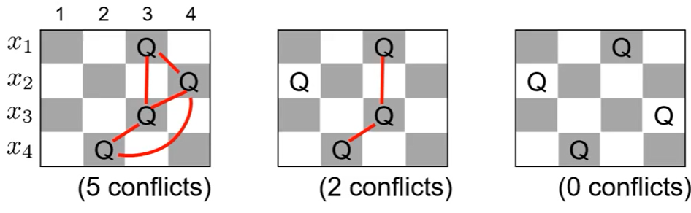

number of conflicts after reassigning one variable

x1 4 4 5 4

x2 2 5? 4 5

x3 4 3 5 3

x4 3 5 5 5

move x2 to 1 where conflict is 2

x1 3 3 2 1

x3 2 2 2 0

x4 2 2 3 2

stuck in local optima → random initial state OR random step on variable (walkSAT)

ex. 4-queen local optima

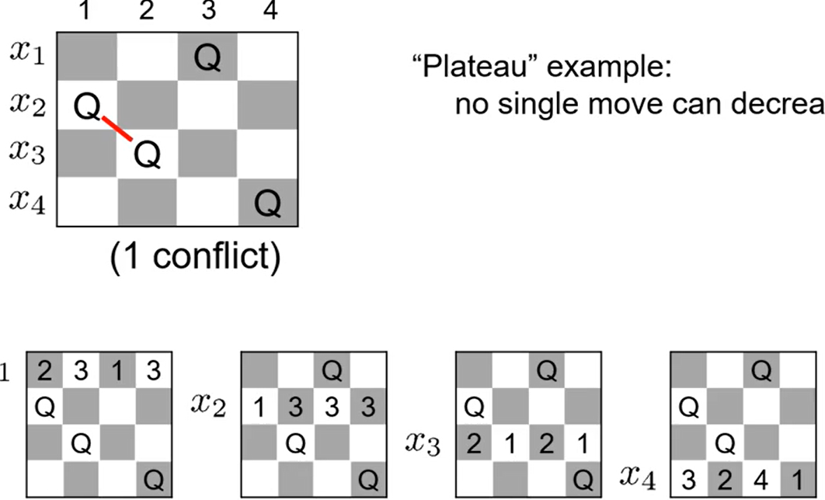

Comparison

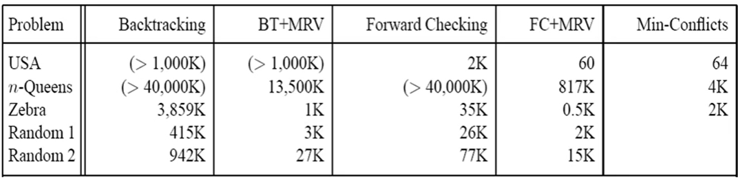

min-conflict cannot prove a problem has no solution

min-conflict cannot guarantee to find a solution

min-conflict is good at dealing with problems which has many solutions (equally good)

Graph

disconnected subproblems (independent)

worst case = $O(n/c d^{c})$ compared to O(d^n) where n = total variable # and c = subproblem variable #

Tree-Structured CSP O(n d^2) for no-cycle graph

select root and do arc consistency from leaves to root

D→F: remove D’s value that is not consistent with F

D→E; B→D; B→C; A→B;

select values from the legal values

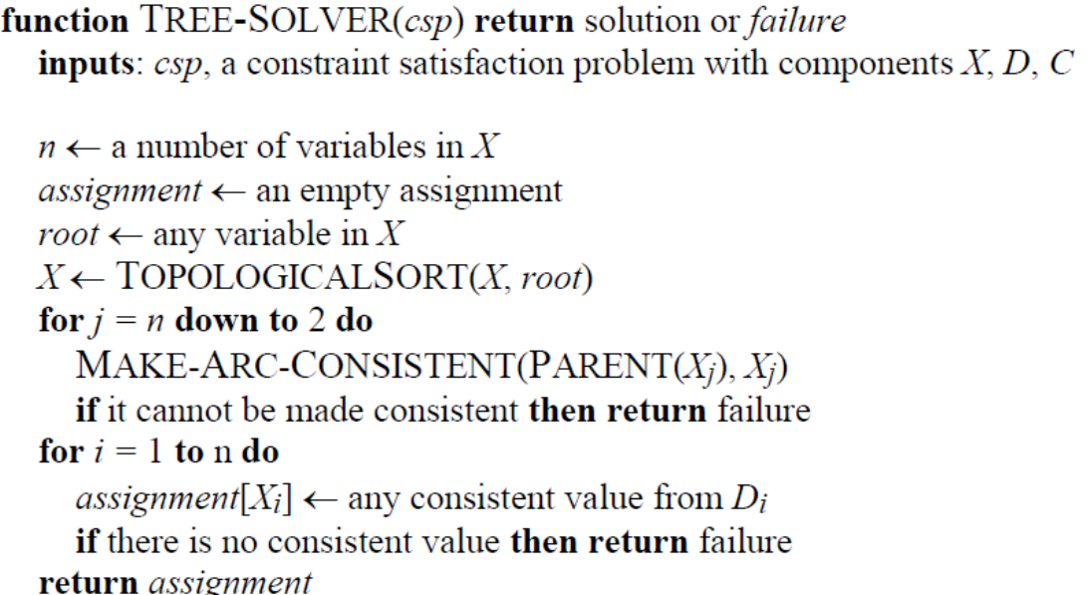

Ex. we can transform a non-tree to tree-structure CSP

first one is cutset conditioning

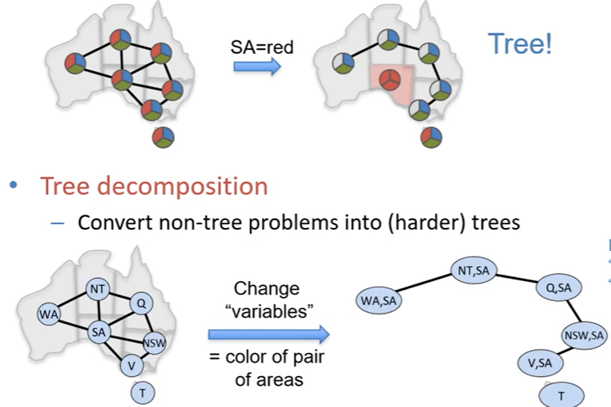

Summary

• CSPs - special kind of problem: states defined by values of a fixed set of variables, goal test defined by constraints on variable values

• Backtracking = depth-first search, one variable assigned per node

• Heuristics: variable order & value selection heuristics help a lot

• Variable ordering (selection) heuristics

– Choose variable with Minimum Remaining Values (MRV)

– Degree Heuristic – break ties after applying MRV

we need disconnect the assigned variable!!!

(https://canvas.eee.uci.edu/courses/58458/files/folder/Past%20Tests/2019?preview=23910508)

• Value ordering (selection) heuristic

– Choose Least Constraining Value

• Constraint propagation

– does additional work to constrain values and detect inconsistencies

– Works effectively when combined with heuristics

• Iterative min-conflicts is often effective in practice.

• Graph structure of CSPs determines problem complexity

– e.g., tree structured CSPs can be solved in linear time.

## – Propositional Logic

Dis/Advantages

Declarative (knowledge separated from inference)

Allows partial/disjunctive/negated information

unlike most programming languages and databases

Compositional

meaning of B_1,1 AND P_1,2 is derived from meaning of B 1,1 and of P 1,2

Meaning in propositional logic is context independent

unlike natural language, where meaning depends on context

BUT has limited expressive power

Ex, Exactly one student in the class got perfect score

Propositional logic – 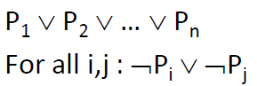

First order logic – 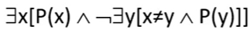

First Order Predicate Calculus(FOPC)

## – First Order Logic (FOL)

Def

Objects = nouns usually( ex people, houses, numbers, colors, baseball games, wars, …

Functions = relations between objects (ex. father of, best friend, one more than, plus, …

Function arguments are objects; value of a function is an object

Predicates/Relations/Properties = verbs/adjectives usually

ex. red, round, prime, brother of, bigger than, part of, comes between, …

Predicate arguments are objects; value of a predicate is a truth value

First argument is generally the subject, the second the object

Basic Elements

constant symbol = nouns = object in the world

function symbol = functions( maps a tuple of objects to an object)

ex. Brother(John)

predicate symbol = verbs = relation (maps a tuple of objects to a truth-value)

ex. Brother(Richard, John) means Richard is brother of John

Model = world = set of domain objects, relations, functions

Sentences are true with respect to a world (model) and an interpretation

Interpretation maps symbols onto the model

Syntax

Term = expression that refer to an object.

Three kinds of terms = constant symbols + variables + function symbols

Atomic Sentences state facts (predicate symbol)

predicate(term 1 term n is true IFF the objects referred to by term1… term_n are in the relation referred to by predicate

Connectives

$⇔$ = biconditional P ⇔ Q is equivalent to (P ^ Q) v (¬P ^ ¬Q)

$⇒$ = implication to disjunction(P ⇒ Q) ↔ (¬P ∨ Q)

Variables

a term without variable = ground term (ex. LessThan( Plus(1,2), 4)

a variable not bound by a quantifier = free variable

Quantifier

$∀ x P(x)$ = for all x, P(x) = $¬∃ x ¬P(x)$

$∃ x P(x)$ = for some x, P(x) = $¬∀ x ¬P(x)$

Rules: 

Ex. 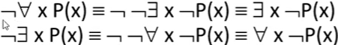

Universal Quantifier usually use implication

Ex. 

if we use ^ to connect instead of =>, that means all x are persons

Universal quantification is conceptually equivalent to:

Conjunction of all sentences obtained by substitution of an object for the quantified variable.

Not a sentence in the logic all logic sentences must be finite.

Existential Quantifier usually use ^ instead of =>

Disjunction of all sentences obtained by substitution of an object for the quantified variable.

Not a sentence in the logic all logic sentences must be finite.

Combining Quantifiers order matters when they are different quantifiers

De Morgan’s Law

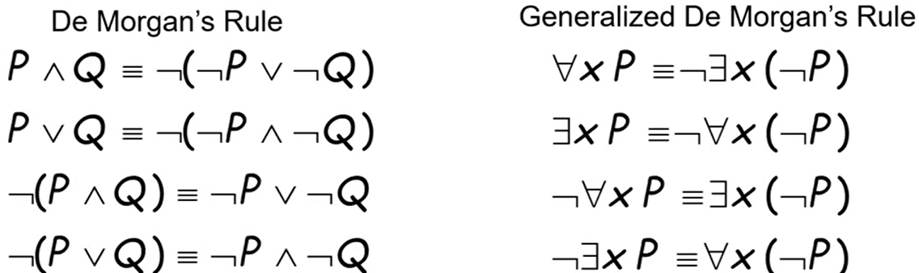

Uniqueness $∃!x = there exists a unique x...$

Equality: term1 = term2 when they are referring the same thing

Ex. for every food, there is a person who eats that food



Mistakes

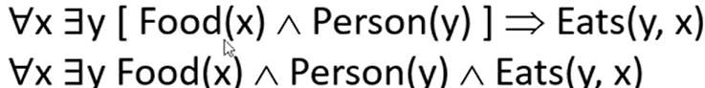

Ex. every person eats every food



Mistakes

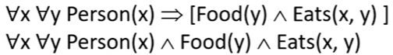

Ex. Every person eats some food



Ex. Everyone has a favorite food



Mistakes

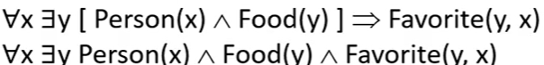

Ex. Some person eats some food



Ex. Some person eats all food

$∃x ∀y Person(x) ∧ (Food(y) => Eats(x,y) )$

Alternative Semantics (?)

Database semantics

Unique names assumption

Every unique constant refers to a distinct object

Domain closure

Each model contains no more domain elements that named by constant symbols

Closed world assumption

Every atomic sentence not known to be true is assumed to be false

Intended Interpretation

Each symbol (constant, function, relation) is mapped to same named object in the model

Semantics PL vs FOL

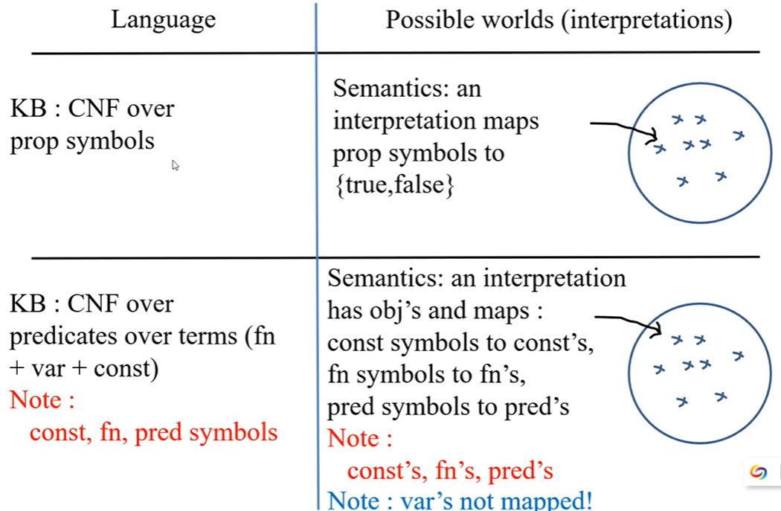

Propositionalization by replace X with ground term

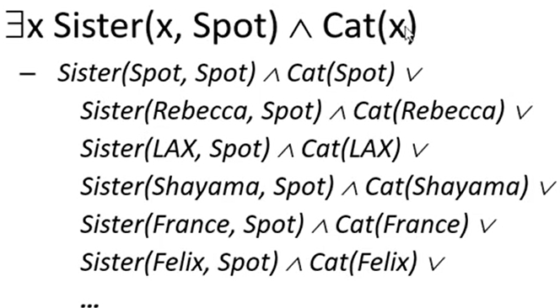

Reduction of FOL to PL

If a sentence α is entailed by an FOL KB, it is entailed by a finite subset of the propositionalized KB

(issue) BUT no algorithm exists that also says no to every non entailed sentence

FOL CNF

(P → Q) ↔ (¬P ∨ Q)

Ex.

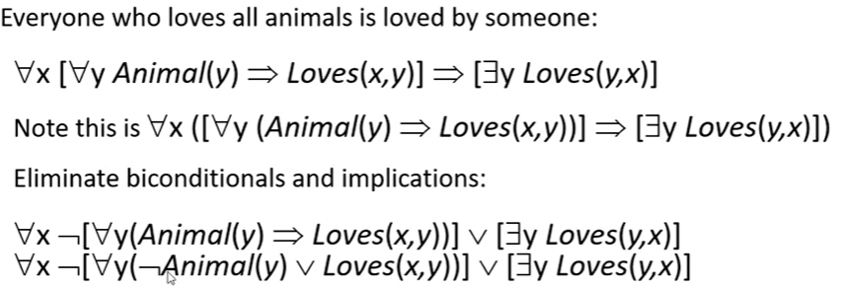



We rename the second y to z

Skolemization: replace Existential variable with a Skolem function

We replace every y with F(x) where x is the universal variable??



Drop universal quantifier



Unification

$θ$ = list of substitution {variable/tem}

Subst($θ$, p) = result of substituting $θ$ into sentence p

unify algorithm takes two sentences p, q and returns unifier if one exists

unify(p, q) = $θ$ where Subst($θ$, p) = Subst($θ$, q)

that make p and q syntactically identical

Ex.

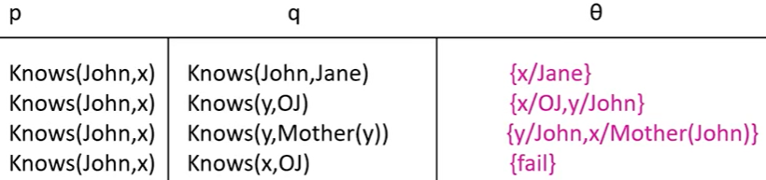



Because we don’t know how to make x and z the same (we only allow substitution of a variable (NOT Function to Function)



Algorithm

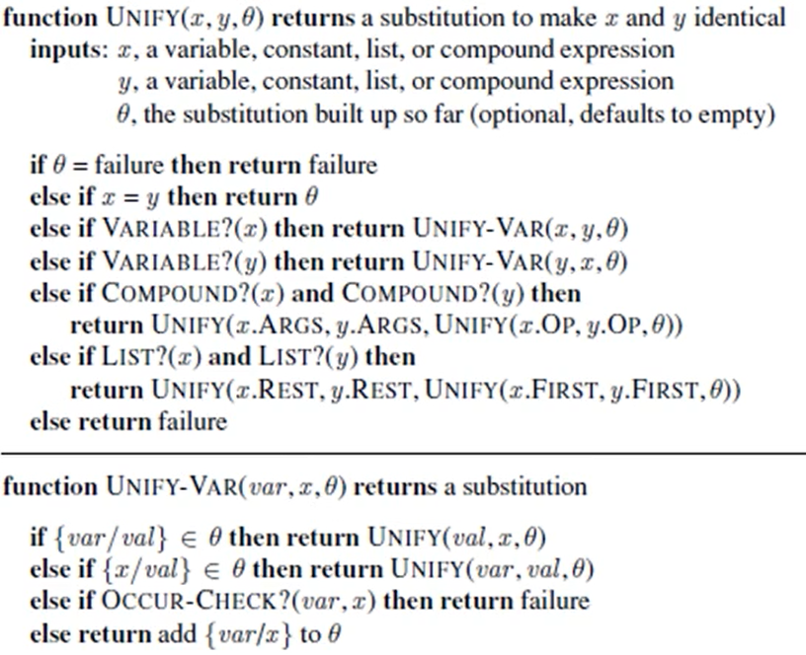

Ex. hard matching example - NP complete

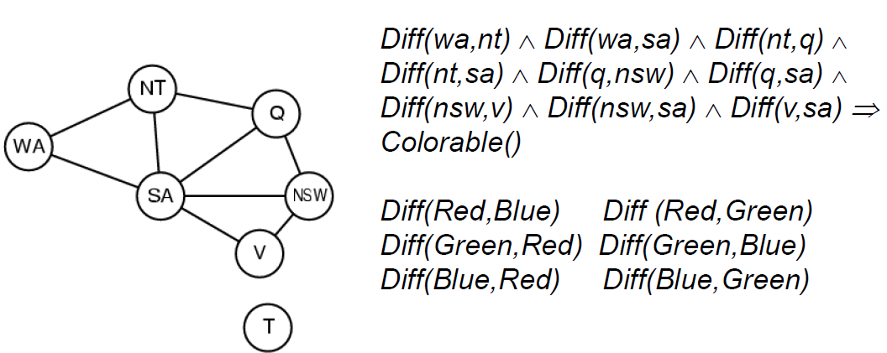

Colorable() is inferred iff the CSP has a solution

CSPs include 3 SAT, so it’s NP-hard

Resolution (must all be CNF) prove by contradiction?

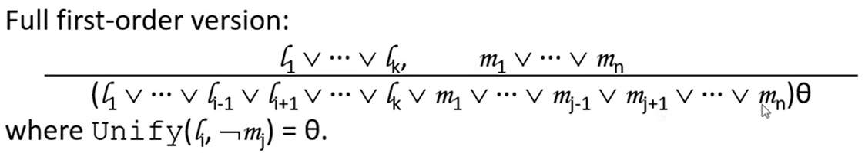

Ex.

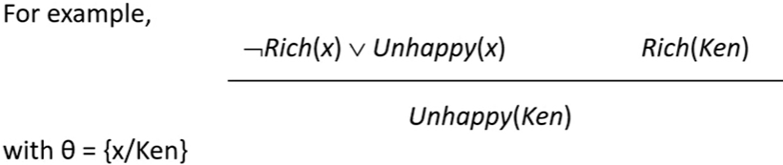

Ex. The law says that it is a crime for an American to sell weapons to hostile nations.



The country Nono, an enemy of America, has some missiles,

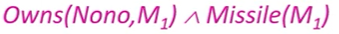

and all of its missiles were sold to it by Colonel West, who is American.



Missiles are weapons Missile(x) ⇒ Weapon(x)

Enemy of America is hostile Enemy(x, American) ⇒ Hostile(x)

West is American American(West)

Nono, is enemy of America Enemy(Nono, America)

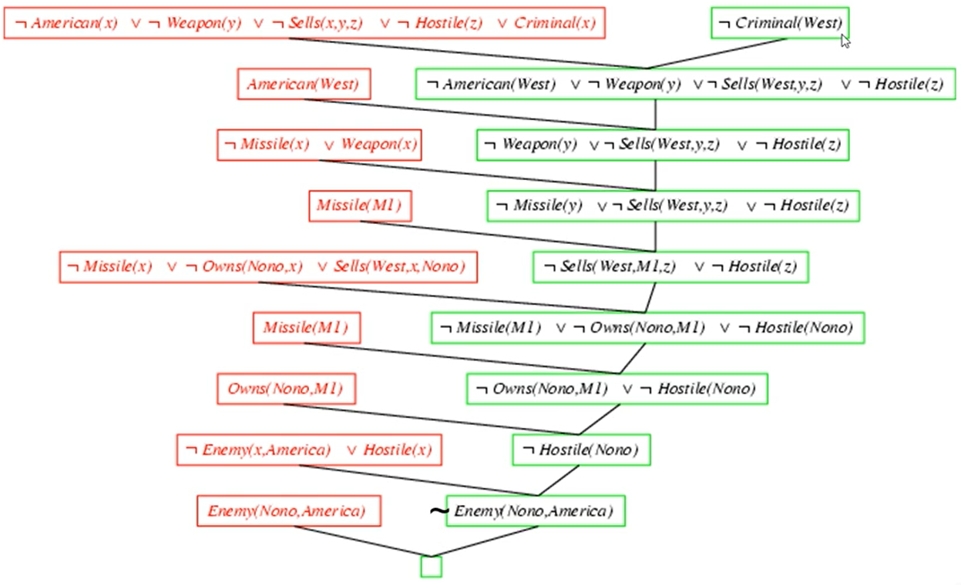

Forward chaining = if we can unify given clauses to prove (from given to desired)

from bottom up

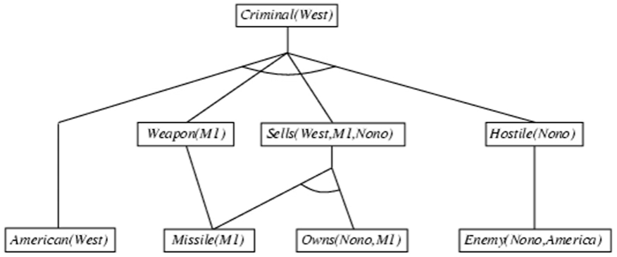

Backward chaining (from desired to given)

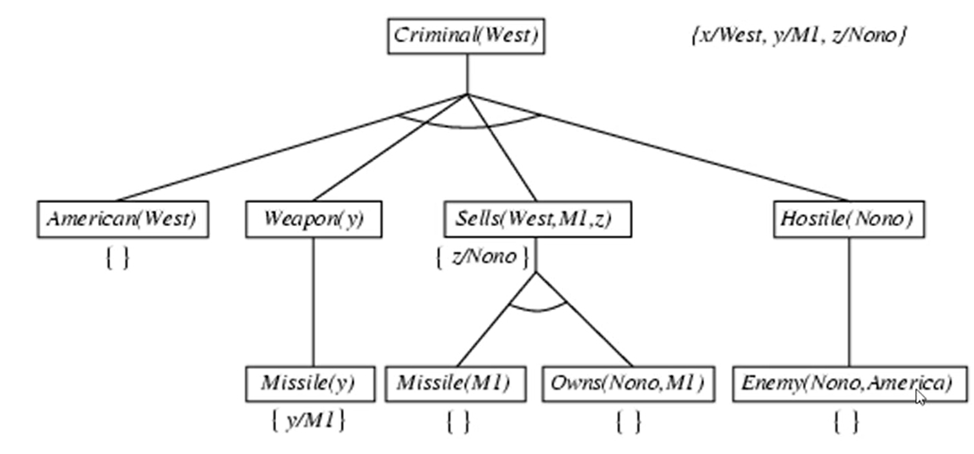

# Classical Planning

Classical planning:

– Actions : deterministic

– States : fully observable, initial state known

– Environment : known and static

– Objective : reach a goal state

• Games

– Agents : 2 (or more) competing

– Objective : maximize utility

• Conformant planning:

– Actions : non-deterministic

– States : not observable, initial state unknown

– Objective : maximize probability of reaching the goal

• Markov decision process (MDP):

– Actions : non-deterministic with probabilities known

– States : fully observable

– Objective : maximize reward

## Situation Calculus

Goal can be described by a sentence:

if we want to have a block on B 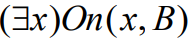

Planning: finding a set of actions to achieve a goal sentence.

fluents = the atoms denotes relations over states

Ex. S0 state in the figure can be declared as

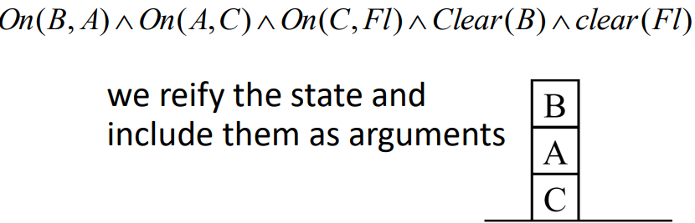

 non-floor with A on top is not clear

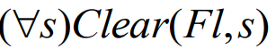 floor is clear

Actions = functions

ex. move(x,y,z) moves block x from block y to z

do(action, from_state) → to_state

positive effect (action → fluent true) move x from y to z → x on z true



negative effect (action → fluent false) move x from y to z → x on y false



Ex.

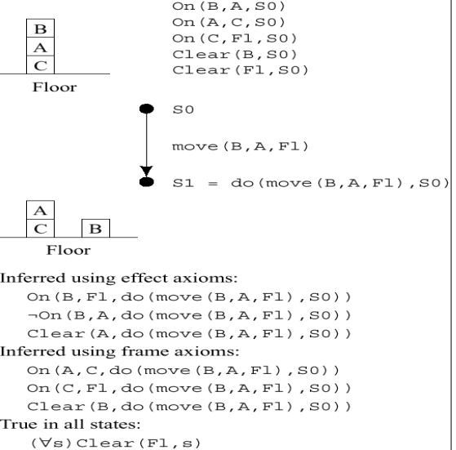

local effect of action

frame axioms = what does not change as a result of an action

ex. move u from v to z

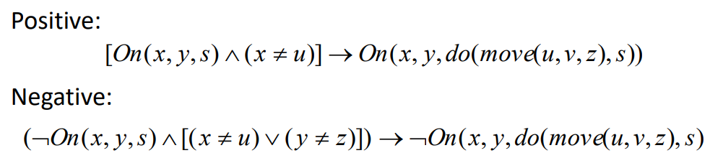

The frame problem: need axioms for every combination of {action, predicate, fluent}

## STRIPS Planning systems

Ex.

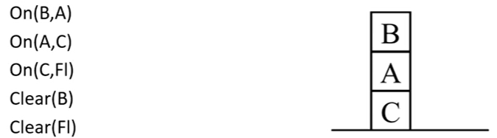

State descriptions: conjunctions of ground functionless atoms

– Factored representation of states!

Initial state is a conjunction of ground atoms

Planning search for a formula satisfying a goal description

– Goal wff: Ex[P(x) ^ Q( y)]

– Given a goal wff, the search algorithm looks for a sequence of actions that

transforms initial state into a state description that entails the goal wff.

A STRIPS operator (action) has 3 parts: (all positive)

– A set PC, of ground literals (**preconditions**)

– A set D, of ground literals called the **delete list**

– A set A, of ground literals called the **add list**

Ex. Move(x,y,z) moves x from y to z

– PC: On(x,y) and Clear(x) and Clear(z)

– D: Clear(z), On(x,y)

– A: On(x,z), Clear(y), Clear(Fl)

state S_i+1 = S_i + A - D

STRIPS vs PDDL

A state is

– a set of positive ground literals (STRIPS)

– a set of ground literals (PDDL)

Closed world assumption :

fluents that are not mentioned are false (STRIPS).

• If a literals is not mentioned, it is unknown (PDDL).

Action schema allows negative literals in PDDL (means delete)

Ex.

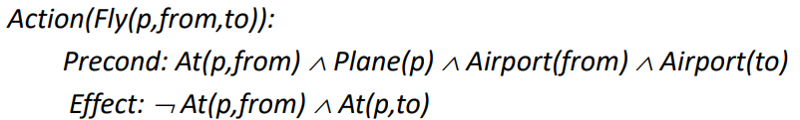

The schema consists of precondition and effect lists :

– Only positive preconditions (STRIPS)

– Positive or negative preconditions (PDDL)

A set of action schemas is a definition of a planning domain.

A specific problem is defined by an initial state (a set of ground atoms) and a goal:

conjunction of atoms, some not grounded (At(p,SFO), Plane(p))

Complexity of classical planning

• Tasks

– PlanSAT = decide if plan exists

– Bounded PlanSAT = decide if plan of given length exists

• (Bounded) PlanSAT decidable but PSPACE-hard

• Disallow neg effects, (Bounded) PlanSAT NP-hard

• Disallow neg preconditions, PlanSAT in P but finding optimal (shortest) plan still NP-hard

STRIPS algorithm

Divide-and-Conquer forward search with islands

Recursive STRIPS algorithm

1. Take a goal from goal set

2. Find a sequence of actions satisfying the goal from the current state, apply the actions, resulting in a new state.

3. If stack empty, then done.

4. Otherwise, the next goal is considered from the new state.

5. At the end, check goals again

Sussman Anomaly ⇒ RSTRIPS cannot find a valid plan

We want On(A,B) and On(B, C) we will destroy one goal if we try to satisfy the other goal

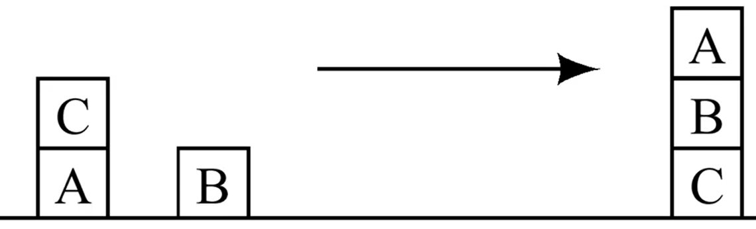

## Planning as Heuristic Search

forward(progression) state-space search

start from initial state, and check applicable actions

Forward search space nodes correspond to individual (grounded) states of the plan state-space

forward chaining fails ⇐ large search space + large branching factor

backward(regression) state space search

start from goal state, and search relevant actions

Ex. forward

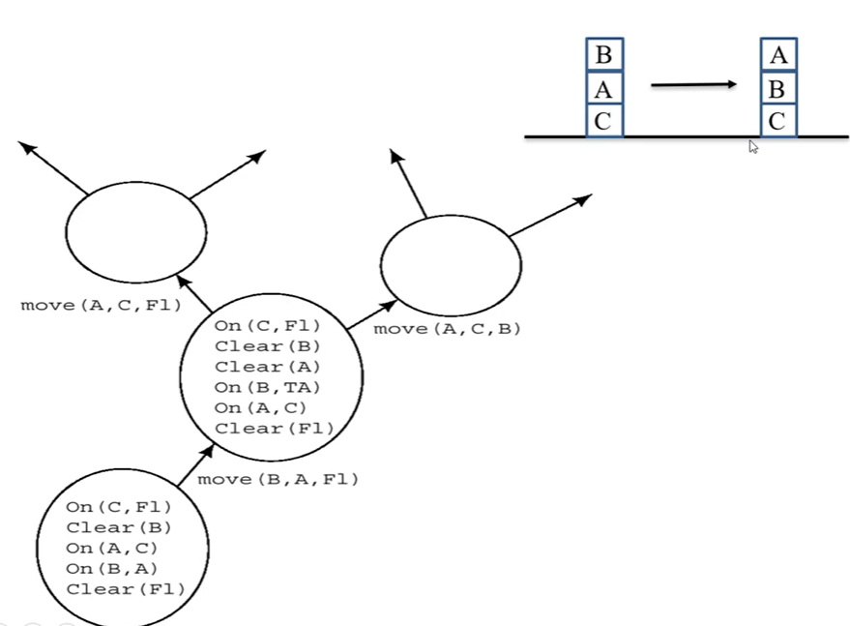

backward

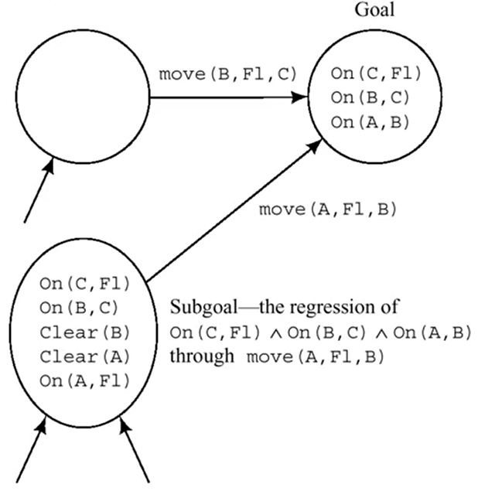

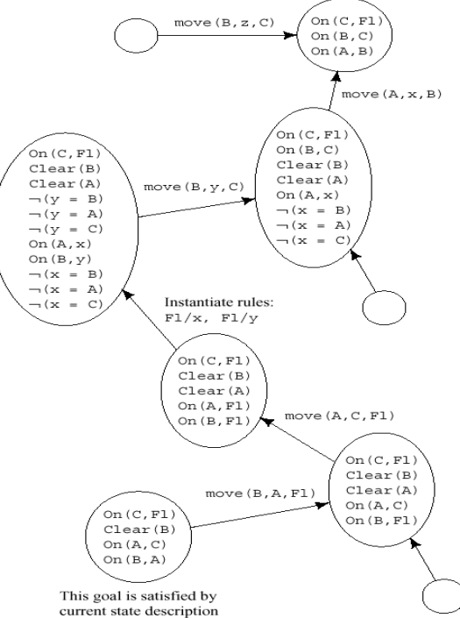

* relax problem idea to get lower bounds on the least number of actions to the goal
* Decomposition (sub-goal independence) compute the cost of solving each sub-goal in isolation, and combine the costs,
* other ideas to remove negative/positive effect/preconditions…, abstraction (combine many states into one), FF(fast-forward planner)...

Planning Graph

* No false negatives
  + if a goal never appears, it is unreachable
* Possible false positives
  + if a goal appears at time i, there is a plan that has no obvious flaw
  + That can be detected by considering pairs of fluents/actions
  + goal estimated to be reachable in 25 steps ⇒ reach in 25+ steps in reality

Def = a sequence of levels that correspond to time-steps in the plan

Level 0 is the initial state.

Each level = a set of literals + a set of actions

Literals are those that could be true at the time step.

Actions are those that their preconditions could be satisfied at the time step.

Works only for propositional planning

Ex. have cake and eat it too

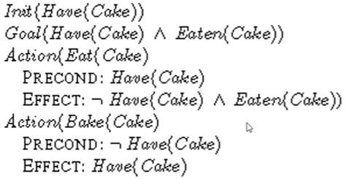

planning graph of “have cake”

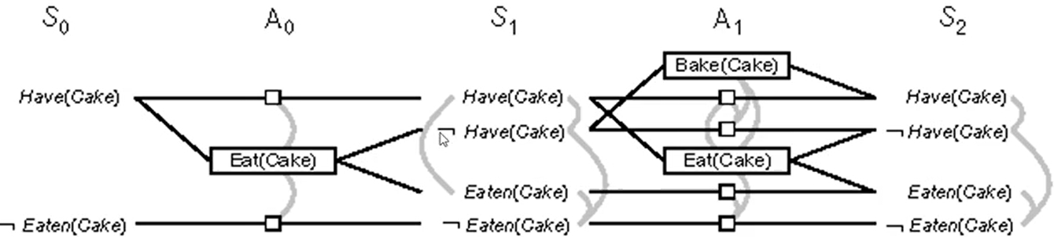

gray edge = Mutual exclusions (mutex) are represented between literals and actions (cannot be executed/true at the same time)

A mutex relation holds between 2 actions on the same level iff any is true:

– Inconsistency effect: one action negates the effect of another.

ex. “Eat(Cake) and persistence of Have(cake)”

– Interference: effect(action) conflicts with the precondition of the other.

ex. “Eat(Cake) and persistence of Have(cake)”

– Competing needs: conflicting preconditions

Example: Bake(cake) and Eat(Cake).

• A mutex relation holds between 2 literals at the same level iff

– one is the negation of the other or if each possible pair of actions that can achieve the 2 literals is mutually exclusive

* Literals increase monotonically
  + Once a literal is in a level it will persist to the next level
* Actions increase monotonically
  + Since the precondition of an action was satisfied at a level and literals persist the action’s precondition will be satisfied from now on
* Mutexes decrease monotonically:
  + if two actions are mutex at level Si, they will be mutex at all previous levels at which they both appear
  + If two literals are not mutex, they will always be non-mutex later
* Because literals increase and mutex decrease it is guaranteed that we will have a level where Si = Si-1 and Ai = Ai-1 that is, the planning graph has stabilized

Planning Graphs for Heuristic estimation

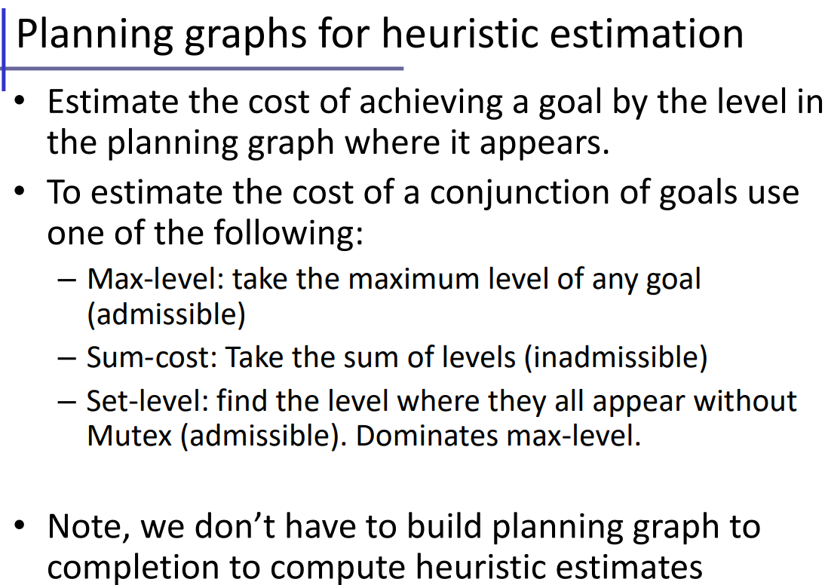

GraphPlan algorithm

• Start with a set of problem goals G at the last level S

• At each level Si, select a subset of conflict-free actions Ai for the goals of Gi

– Goals Gi are covered

– No 2 actions in Ai are mutex

– No 2 preconditions of any 2 actions in Ai are mutex

• Preconditions of Ai become goals of Si-1

• Success iff G0 is subset of initial state

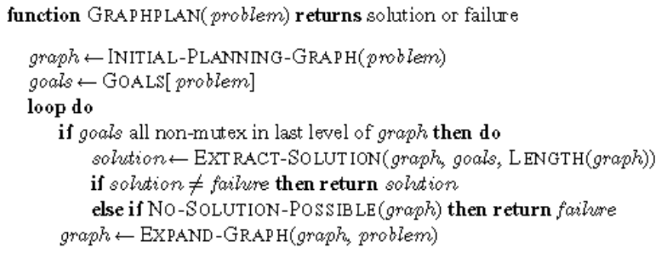

Choose an action during backwards search:

• Use greedy algorithm based on the level cost of the literals.

For any set of goals:

• 1. Pick first the literal with the highest level cost.

• 2. To achieve the literal, choose the action with the easiest preconditions first (based on sum or max level of precondition literals

## Planning as Satisfiability

• Index propositions with time steps:

– On(A,B)_0, ON(B,C)_0

• Goal conditions:

– the goal conjuncts at time T, T is determined arbitrarily.

• Initial state :

– Assert (pos) what is known, and (neg) what is not known.

• Actions: a proposition for each action for each time slot.

– Exactly one action proposition is true are at t if serial plan is required

• Formula : if action is true, then preconditions must have held

• Successor state axioms need to be expressed for each action

(every state must have a reason) F^t+1 ⇔ ActionCausesF^t OR (F^t AND ActionCausesNotF^t)

SATPlan

Guess length of plan T

Initial state : conjunction of initial state literals and negation of all positive literals not given

For each action and each time slot t 

Successor state axioms : (if something became true, an action must have caused it)

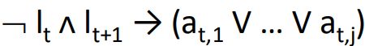

Exclusion axiom : exactly one action at a time

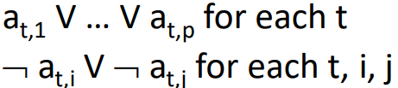

* To have a single plan we may have a mutual exclusion for all actions in the same time slot.
* We can also choose to allow partial order plans and only write exclusions between actions that interfere with each other.
* Complexity = 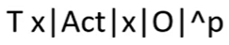 where O = # objects, p = scope of atoms

Ex. flashlight problem (put two batteries in flashlight and flashlight is on cap)

4 objects = Cap, Battery1, Battery2, Flashlight

2 predicates : On (e.g. On(C,F)), In (e.g. In(B1,F))

Initial state = On(C, F) #cap is on flashlight

Assume initially : not In(B1,F) and not In(B2,F)

Goal : On(C,F), In(B1,F), In(B2,F)

3 actions

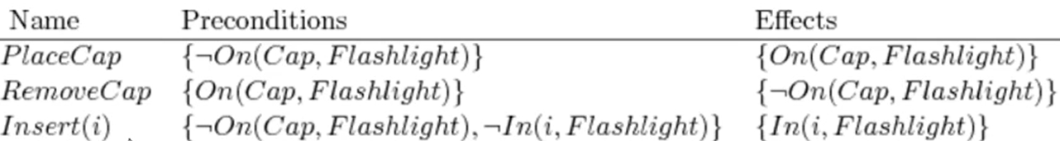

assume Plan has 4 steps

initial state = O(C,F,1) ^ not I(B1,F,1) ^ not I(B2,F,1)

goal state = O(C,F,5) ^ I(B1,F,5) ^ I(B2,F,5)

 = (not a) OR (p(a) ^ e(a))

For PlaceCap: not PC_k OR (not O(C,F,k) ^ O(C,F,k+1))

…

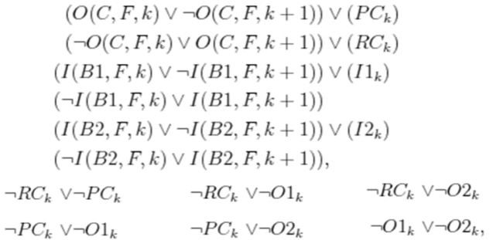

solutions

RC1, IB1_2, IB2_3, PC_4

RC1, IB2_2, IB1_3, PC_4

Partial Order Planning

A state is a partial incomplete partially ordered plan

Operators transform plans to other plans by:

– Adding steps

– Reordering

– Grounding variables

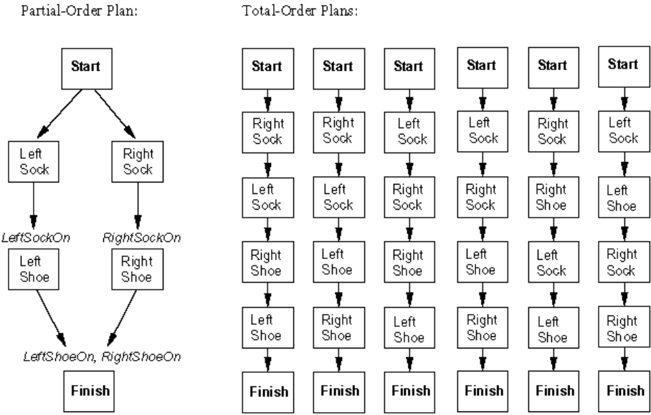

# Probabilistic Reasoning

Depends on my preferences for missing flight vs. time spent waiting, etc.

**Utility theory** is used to represent and infer preferences

Expected Utility

Ex. goal is to maximize utility

– P(A25 gets me there on time | ...) = 0.04

– P(A90 gets me there on time | ...) = 0.70

– P(A120 gets me there on time | ...) = 0.95

– P(A1440 gets me there on time | ...) = 0.9999

– Utility(on time) = $1,000

– Utility(not on time) = −$10,000

E(Utility(A25)) = 0.04*$1,000 + 0.96*(−$10,000) = −$9,560

E(Utility(A90)) = 0.7*$1,000 + 0.3*(−$10,000) = −$2,300

E(Utility(A120)) = 0.95*$1,000 + 0.05*(−$10,000) = $450

E(Utility(A1440)) = 0.9999*$1,000 + 0.0001*(−$10,000) = $998.90

Decision theory= probability theory + utility theory

Basics

Types of Random Variables:

Boolean e.g., Cavity (= do I have a cavity?)

Discrete e.g., Weather is one of {sunny, rainy, cloudy ,snow}

Continuous within constraint e.g., Current temperature is bounded by (10°, 200°)

Domain values must be exhaustive and mutually exclusive:

One of the values must always be the case (Exhaustive)

Two of the values cannot both be the case (Mutually Exclusive)

Ex. Example: Coin flip

Variable = R = the result of the coin flip

Domain = {heads, tails, edge} <-- must be exhaustive

– P(R = heads) = 0.4999 }

– P(R = tails) = 0.4999 } <-- must be exclusive

– P(R = edge) = 0.0002

Posterior/Conditional Probability P(a | b) = a given b = P(a,b) / P(b)

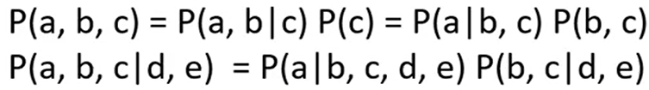

Chain rule



Joint Probability P(a, b) = a and b

Sum Rule (rule of total probability)



Ex. Determine probability of catching a fish

Given a set of probabilities P(CatchFish, Day, Lake) where:

▪ CatchFish = {true, false}

▪ Day = {mon, tues, wed, thurs, fri, sat, sun}

▪ Lake = {blue lake, ralph lake, crystal lake}



Bayes’ Rule



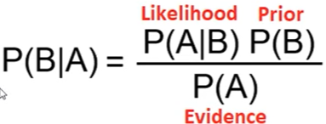

likelihood = casual(generative) model eg medical condition

P(B|A) = diagnostic model eg. symptoms

Ex. 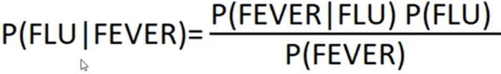

P(a OR b) = P(a) + P(b) - P(a, b)

P(a) = degree of belief that event a is true (unconditional, marginal probability)

Full joint distribution ⇒ cross product all variable ⇒ all possible results ⇒ answer queries

Ex. normalize to compute conditional probability



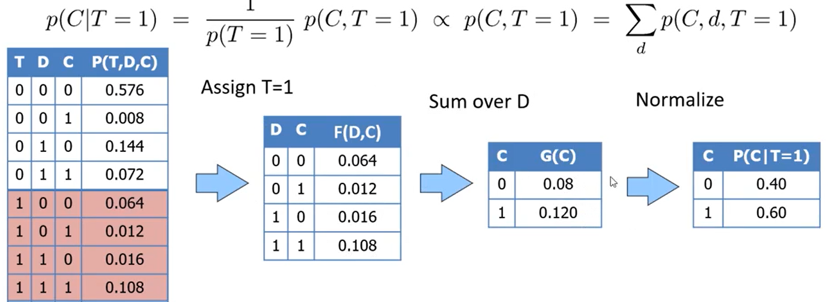

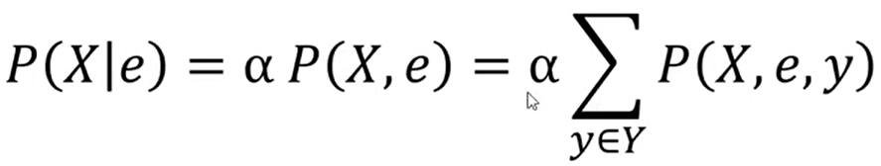

Independent Variables

X and Y are independent

p(X,Y) = P(X) * P(Y)

P(X|Y) = P(X) and P(Y|X) = P(Y) (if p(Y), p(X) > 0)

⇒ we don’t need fully joint distribution

X and Y are independent given Z

P(X,Y|Z) = P(X|Z) * P(Y|Z)

P(X|Y,Z) = P(X|Z) and P(Y|X,Z) = P(Y|Z)

Ex. within the group, two symptoms are independent. Among all groups, there is a pattern ⇒ some dependencies

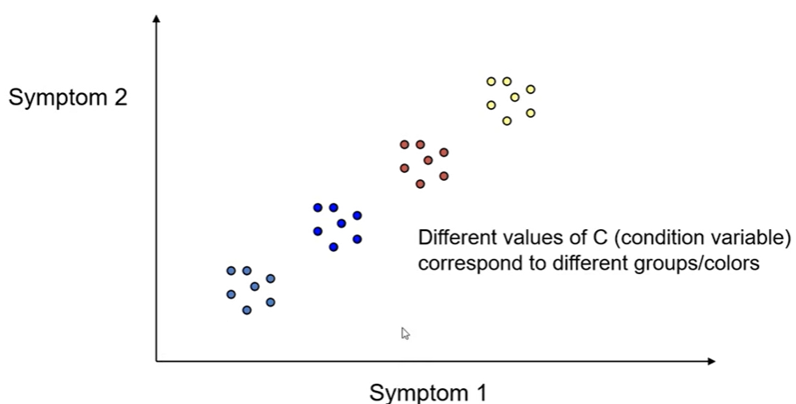

Ex. A box contains two coins: one regular coin, P(heads) = .5, and one fake two-headed coin, P(heads)=1. I choose a coin at random and toss it twice. Define the following events.

– A = First coin toss results in heads

– B = Second coin toss results in heads

– C = Coin 1 (regular) has been selected

 ⇒ A and B are not independent

 ⇒ A and B are independent given C

Naive Bays



Full Joint vs Conditional Independence

• Example : 4 Binary Random Variables (A,B,C,D)

– Full Joint Probability Table with 16 rows

– Conditional Independence

• P(A,B,C,D) = P(A) P(B|A) P(C |A, B) P(D| A,B,C) (no saving yet..)

• If B,C,D are conditionally independent given A, i.e.

• if... P(C|A, B) = P(C |A), P(D|A,B,C) = P(D|A) [Naïve Bayes Model]

– P(A,B,C,D) = P(A) P(B|A) P(C|A) P(D|A)

– 4 Tables. With at most 4 rows

## Bayesian Network

Chain rule of probability

p(x,y,z) = p(x) p(y|x) p(z|x,y)

p(x,y,z) = p(x) p(y|x) p(z|x) if y,z are cond. indep. given x (we can drop y in 3rd item)

p(x,y,z) = p(x) p(y) p(z) if y and x are indep. and z and x are indep

DAG (directional acyclic (no cycle) graph)

Node = random variable

Directed Edge = conditional dependence

Absence of Edge = conditional independence

ex. p(x,y,z) = p(x) p(y|x) p(z|y,x)

// p(z|y,x) can be p(z|y) because no → between x and z

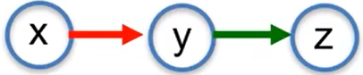



Ex. p(a,b,c) = p(c|a,b) p(a) p(b) p(a,b,c) = p(c|b) p(b|a) p(a)

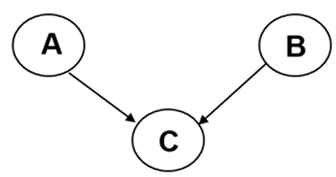 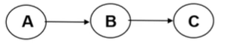

parent ⇔ conditioning variables (RHS)

Building Bayesian Networks

Ex.

– B = a burglary occurs at your house

– E = an earthquake occurs at your house

– A = the alarm goes off

– J = John calls to report the alarm

– M = Mary calls to report the alarm

Order the variables in terms of influence: {E, B} -> {A} -> {J, M}

Chain rule: p(J,M,A,E,B) = p(J|A) p(M|A) p(A|E,B) p(E) p(B)

5 items ⇒ 5 tables

p(J|A) we need 2 rows = J’s true when A is true/false

p(M|A) we need 2 rows

p(A|E,B) we need 4 rows = A’s true when E,B is true/false

p(E) and P(B) we only need 1 row for each

8 of those are conditional probabilities

* # rows = # combinations of parents/conditioning variables

# probabilities = O(n* 2^k) where k = # parents at maximum.

# probabilities = O(2^n) for joint distributions

Independency

ex. Given Alam, John and Mary is cond. indep. because the value(alarm) is set

without knowing alarm, Mary and John is dependent, meaning that, if we know some information about Mary, we can infer some information about John

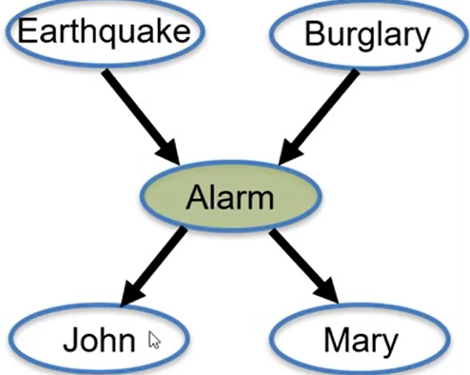

Given A, B and J are independent (breaks the chain with known value)

Without knowing A, E and B are independent

Given A, E and B are NOT cond. indep.

* knowing result, we can infer causing variables

D-separation

Markov Blanket area of X

X’s parent/children

X’s children’s parent

X is cond indep. of its non-descendants (rest of the network) GIVEN value of its parent (gray Markov Blanket area)

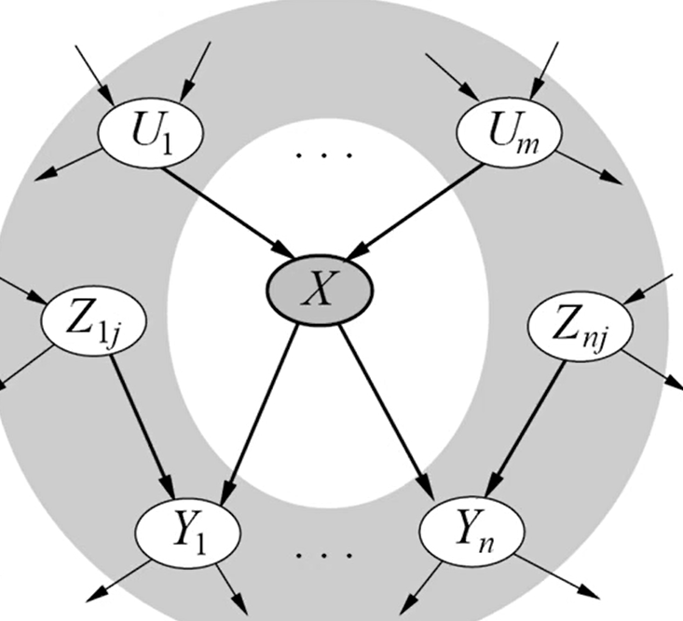

A path is “inactive” if it passes through:

Given V, X and Y are cond indep in the first two situations  
Without V’s value, X and Y are cond indep in third situation

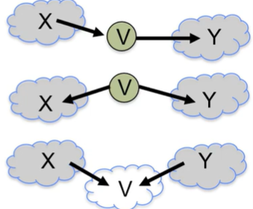

ex. V known → U and Y are cond indep ⇒ X and Y are indep

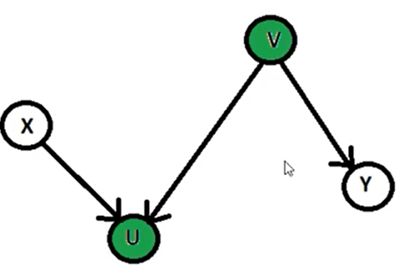

U and Y are cond indep because all path are inactive UVY and UWY

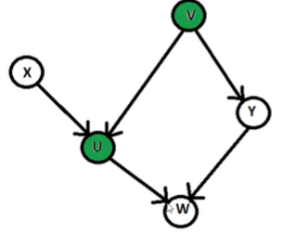

Queries

X = { X1, X2, ..., Xk } = query variables of interest

E = { E1, ..., El } = evidence variables that are observed (given)

Y = { Y1, ..., Ym } = hidden variables (not given)

Ex. query variables are A and B

hidden variable = C

evident variable = D

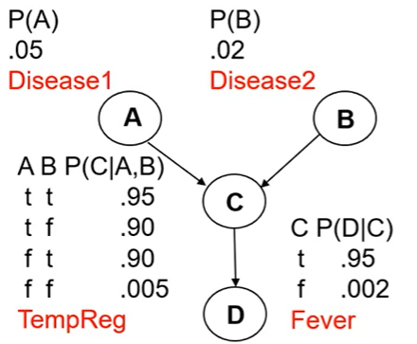

What is the posterior conditional distribution of our query variables, given that fever was observed?

P(A,B|d) = α Σ_c P(A,B,c,d)

= α Σ_c P(A)P(B) P(c|A,B) P(d|c)

= α P(A)P(B) Σ_c P(c|A,B) P(d|c)

What is the most likely posterior conditional assignment of values to our query variables, given that fever was observed?

argmax{a,b} P( a, b | d )

= argmax{a,b} Σ_c P( a,b,c,d )

= { a, not b }

compute P(q|e)

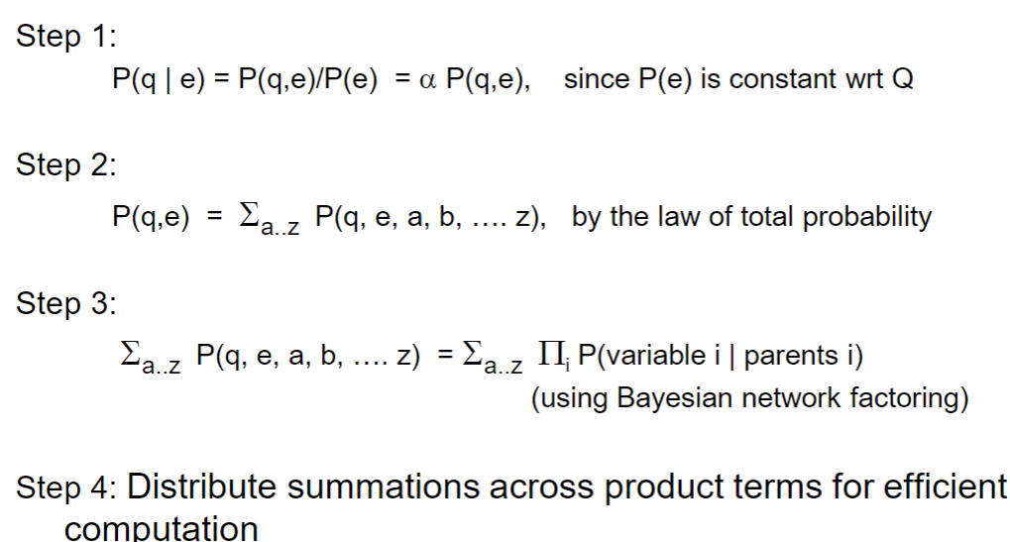

# Machine Learning

## – Basics, Linear Regression

Types

supervised learning - to predict target value

classification (discrete value) or regression (continuous value)

unsupervised learning - no target value

similarities, patterns, explaining features.

reinforcement learning

Data types

binary, category, integer… even missing values

Ex. load data to a matrix

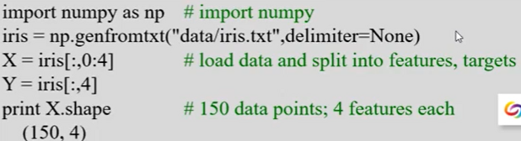

Prediction

Nearest Neighbor predictor: choose the y of nearest known x

Linear regression predictor: f(x) = predicted y

measuring errors

mean square error

mean average error (more stable for outliers)

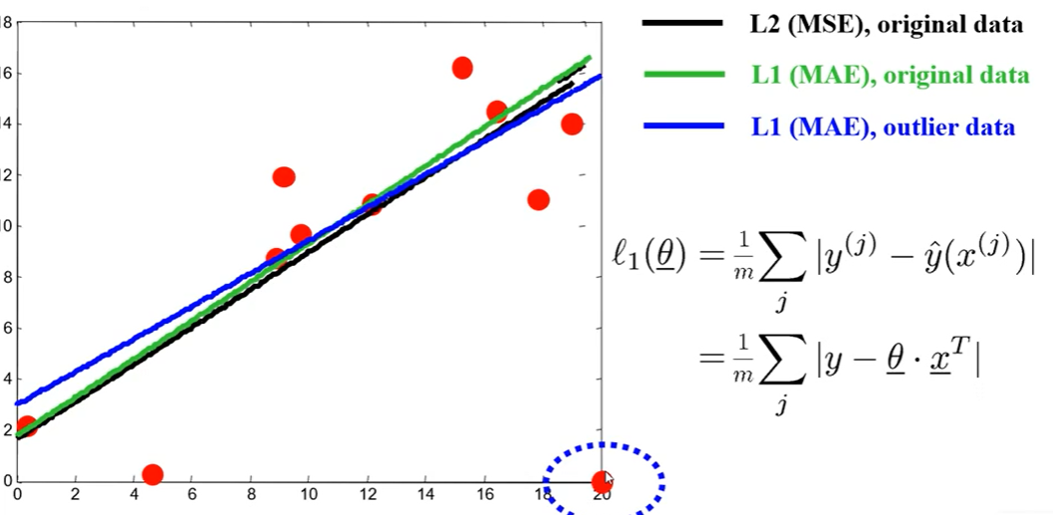

Classification

decision boundary → separate different results

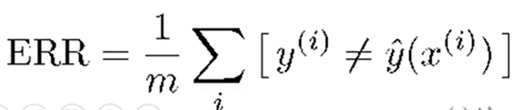

Overfitting

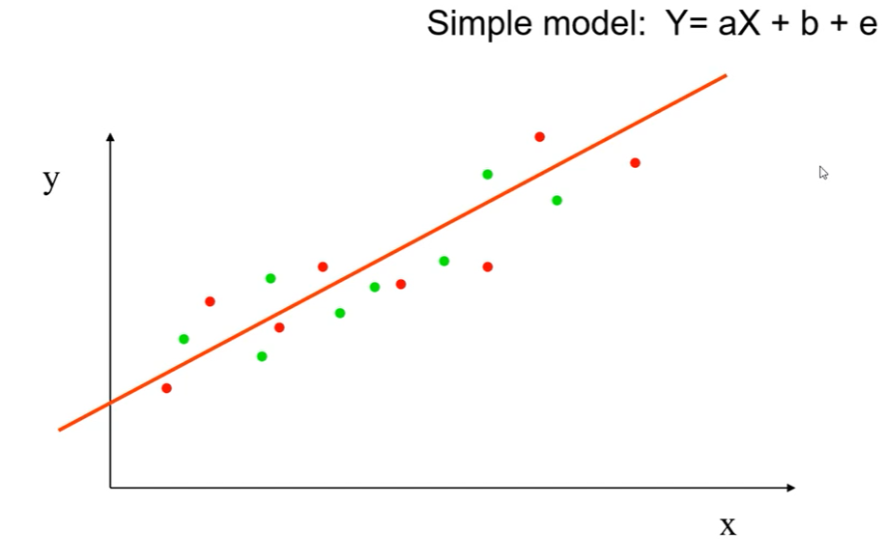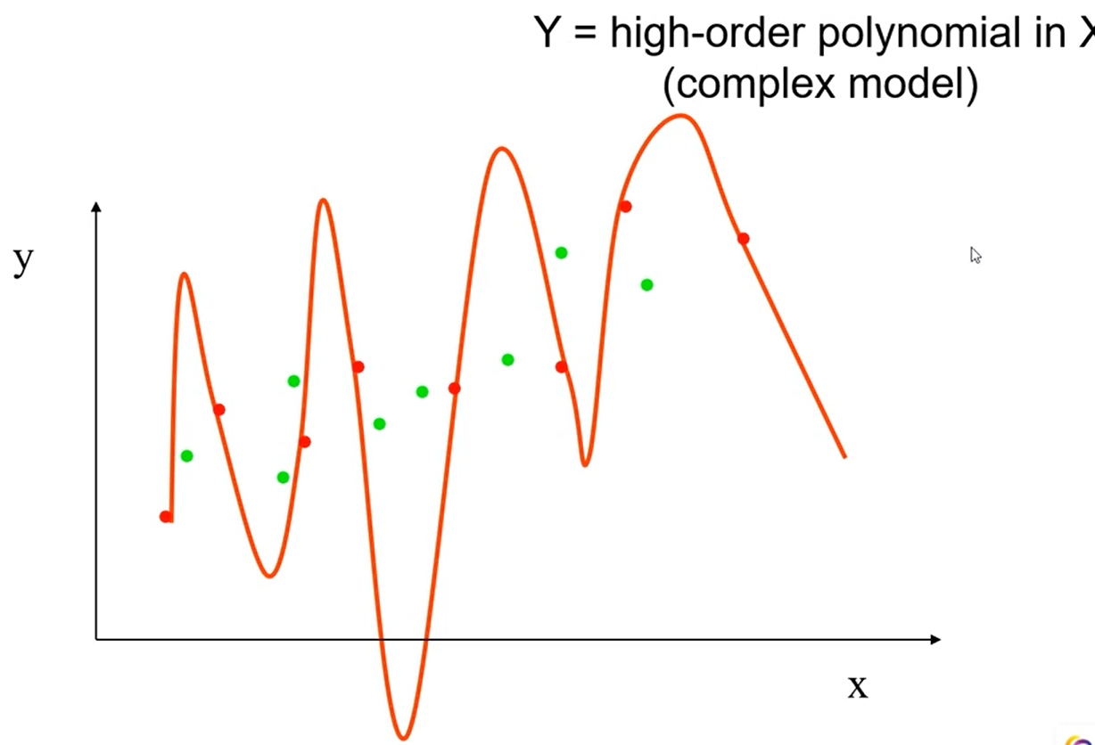

Overfitting ⇒ fewer errors in training, but might increase errors in test data

remove features (feature selection)

get more data…

Underfitting ⇒ more errors in both training and test data

add features, increase model complexity

use less data…

Bias = error due to assumptions in the model (associated to model complexity)

Variance = error due to variance in training data (how to split test/training data)

constant (0) high bias & low variance linear (1)

cubic (3) good balance (9) low bias & high variance

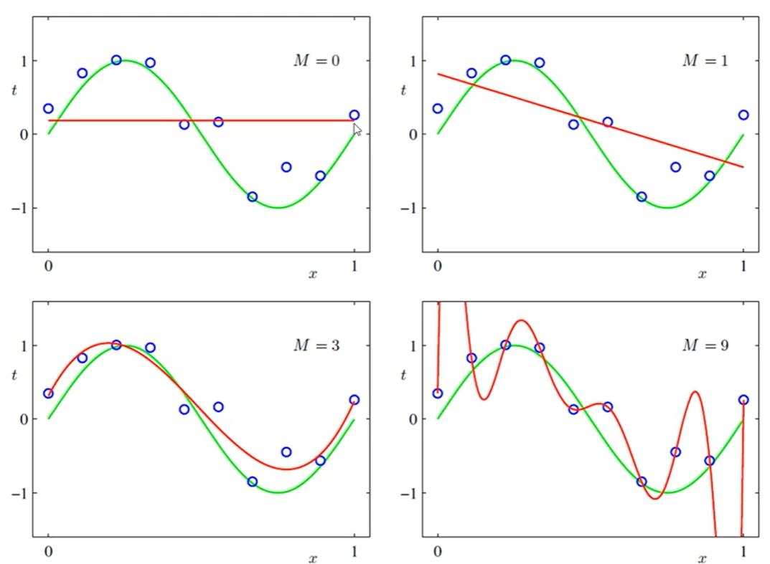

* changing training data ⇒ model changes a lot ⇒ high variance

Ways to split data

cross-validation (k-fold = hold one to validate) error = avg of overall

Notation

$\hat{y}=θ_{0}+θ_{1}x_{1}+...$ We define “feature” x0 = 1 (constant)

Then $\hat{y}=θ_{}x^{T} where θ_{}=[θ_{0}, θ_{1}..., θ_{n}] and x =[1,x_{1},...x_{n}]$

Error = $y-\hat{y}=y-θ_{}x^{T}$ MSE = $\frac{1}{m}\sum{}{Error}^{2}$

Gradient descent

cost function = $J(θ)$ we want minimal cost ⇒ negative derivative wanted

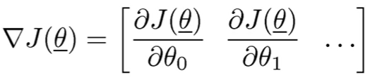

Gradient of MSE

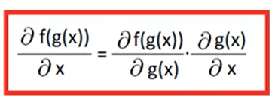

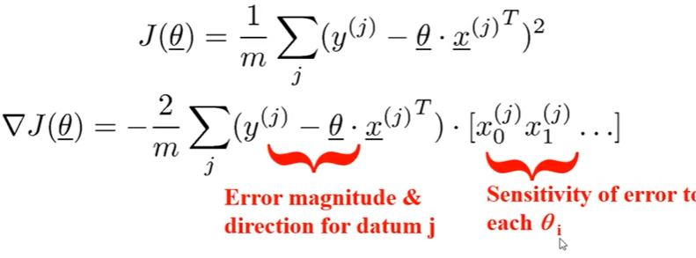

* Step size can be too large or too small ⇒ not able to reach minimal (we can have changing step size)
* sensitive to starting point (local minima)
* Stochastic/online gradient descent = pick j randomly and update $θ$ with only j…
  + computationally faster when dealing with more data (especially at beginning)
  + no longer strictly descent (stopping condition is hard to evaluate)
  + mini-batch updates (compute/apply gradient descent with this batch)

Nearest Neighbor

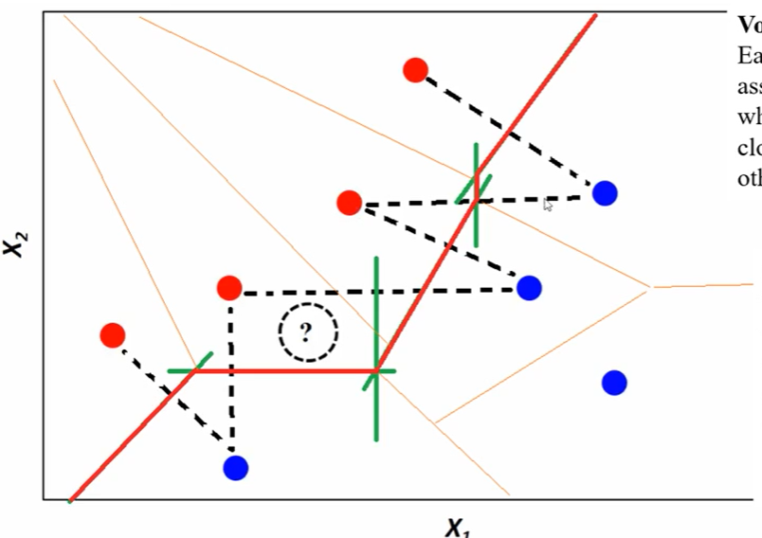

draw the decision boundary with (r, b) pairs

KNN

K = 1 ⇒ no error, closest neighbor is itself

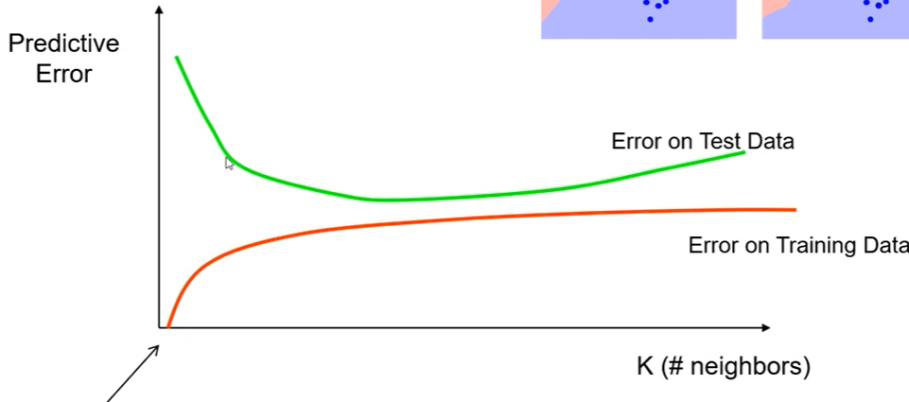

select k with validation data

as n features increase, optimal k tends to increase as O(log(n))

diff distance measures, weighted distance

## – Decision Trees

Nested if else statements to form a tree-like structure

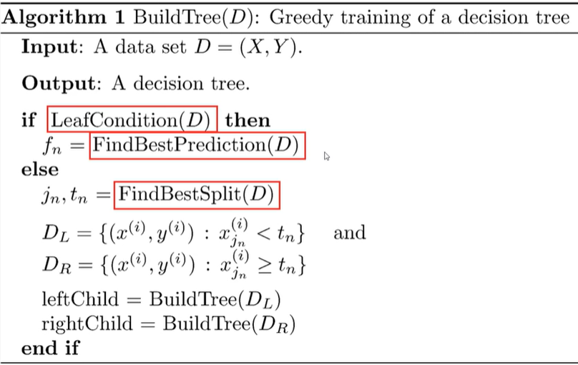

When to stop? (decide it’s a leaf node)

error <= some constant…

value ⇐ majority

How to split the test node?

greedy - score all possible features and split

score function measure “purity” of data after split (how easy we can predict after split)

Entropy = - sum (p(x) log(p(x)) ) so for two outputs H = -p log(p) - (1-p) log(1-p)

Ex.

before split, H(Y) = – ⅚ log(⅚) – ⅙ log(⅙) = 0.65

after split, 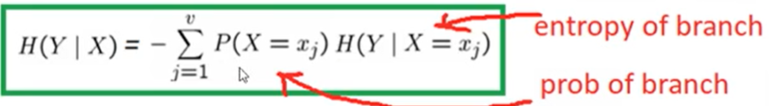

if split on X1, H(Y|X1) = 4/6 * 0 + 2/6 * (- log(½)) = 2/6

information gain IG = H(Y) - H(Y|X)

IG(X1) = 0.65-0.33 = 0.32

IG(X2) = 0.65 - (½ * (-1/3log(⅓) - 2/3log(⅔)) = 0.65 - ½ * 0.91) = 0.195

so splitting on X1 is better

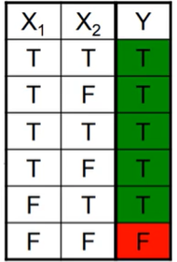

For regression, common measure is variance reduction

Ex. 

21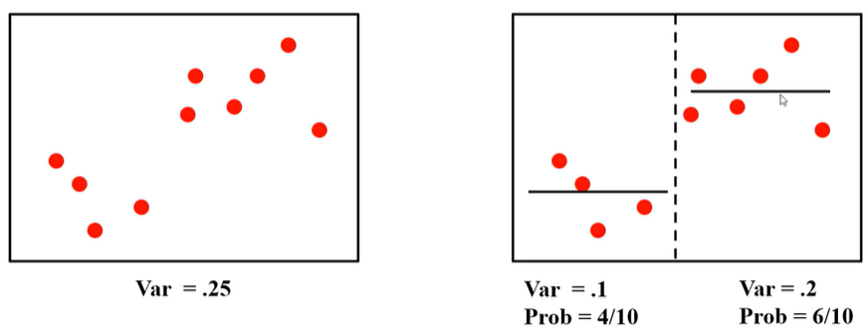

Chi- squared test to decide if a split is necessary

## – Neural Nets

## – Reinforcement Learning

Different from supervised learning

no target value to predict.

Learn policy (best action of a state by maximizing cumulative reward)

Agent decides actions, gets next observation/reward

Environment executes actions, computes observation and reward

Sequential Decision Making

goal = maximize long-term reward

Markov (MDP)

“future is independent of the past given the present”

state transition probability 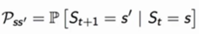

Ex.

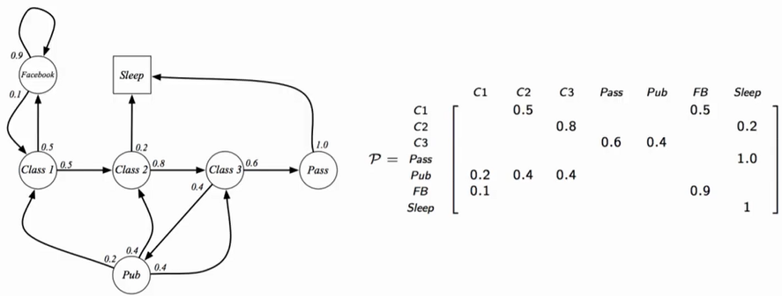Sleep (square) is the terminal state

MRP (Markov Reward Process) 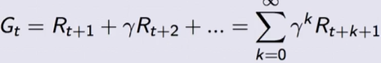

$γ$ = the inflation rate

State value = expected return of starting from this state 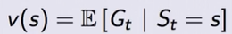

Ex. $γ$ = ½，R(FB) = -1, R(Sleep) = 0, R(C1/C2/C3) = -2, R(Pass) = 10, R(P) = 1

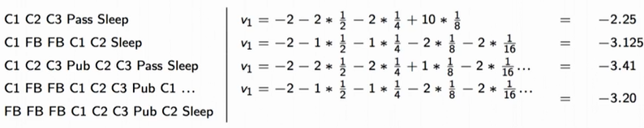

averaging the sum of Gt, we get the state value

Ex. v(s) = R(s) for $γ$ = 0

Bellman Equation of MRP

v(s) = R(s) + $γ$* v(S_t+1) = immediate reward(current state) + inflated rate * next reward(next state)

Ex. $γ$ = 1. v(C3) = R(C3) + 0.4*1*v(Pub) + 0.8*1*v(Pass)

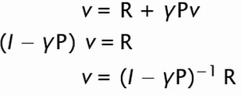

expectation 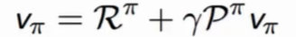with fixed policy

Policy = action to take given state 

fully defines behavior of agent

depends on current state (not the history) and is time-independent

state-value function 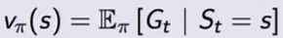= value following policy

 (one state look-ahead)

usually next state value is given

ex. v(

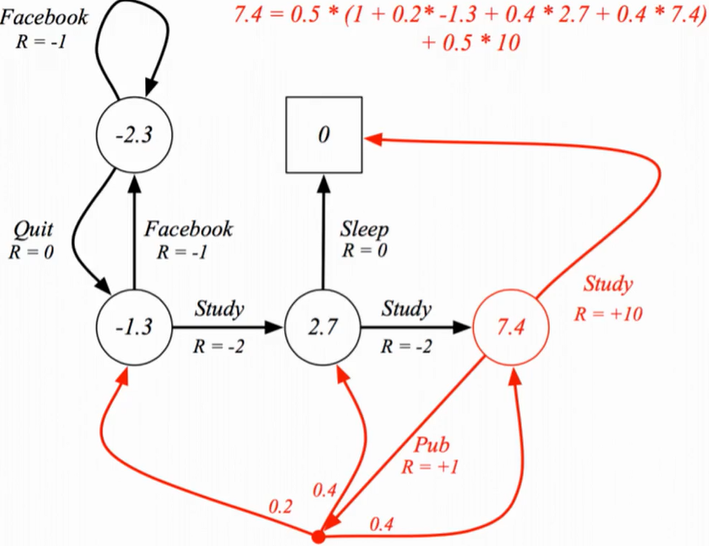

action-value function 

from state s, take action a and then follow policy (a may not follow policy)

optimal value function of state-value and action-value

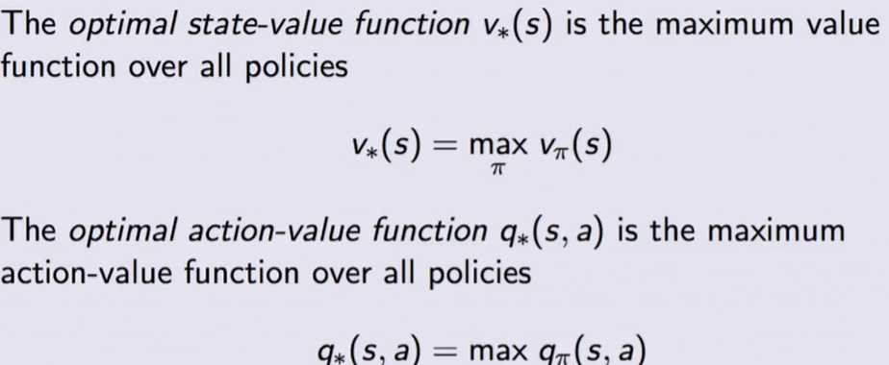

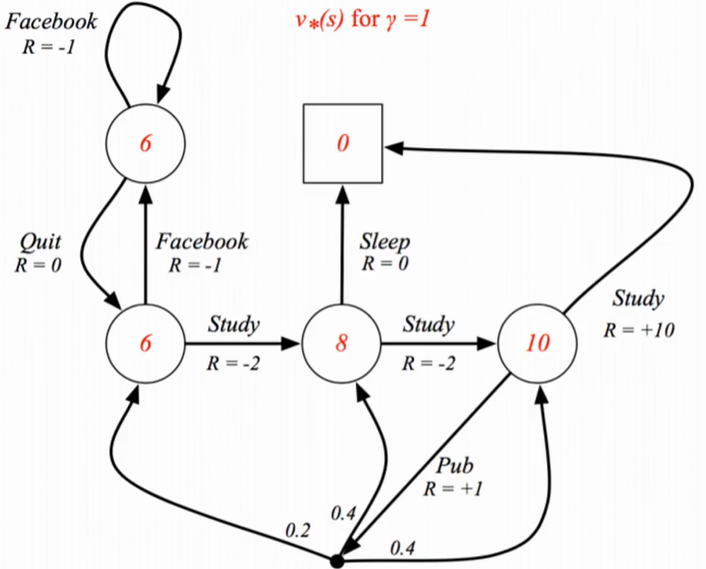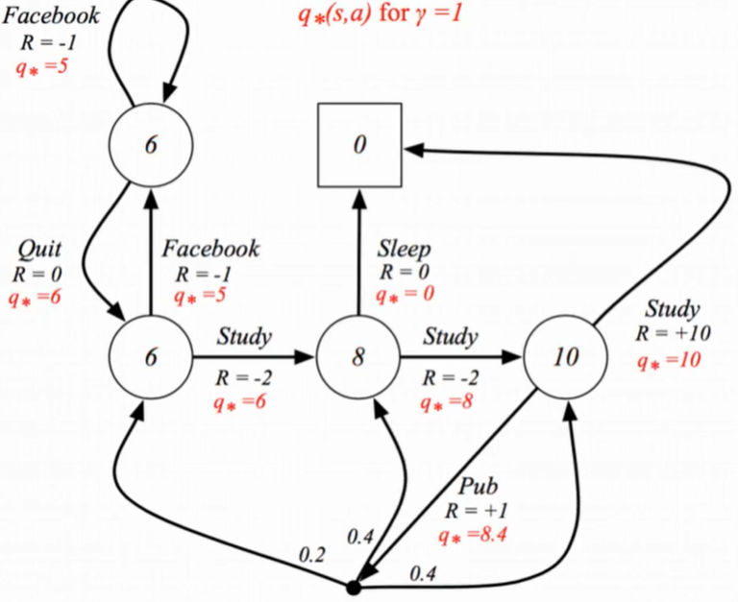

Optimal Policy

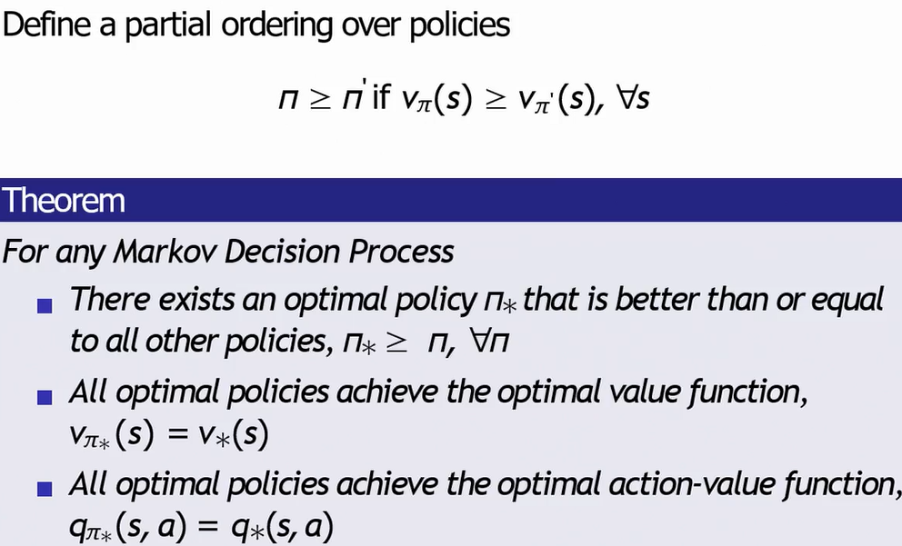

Ex. for this node optimal = 6 going to C2

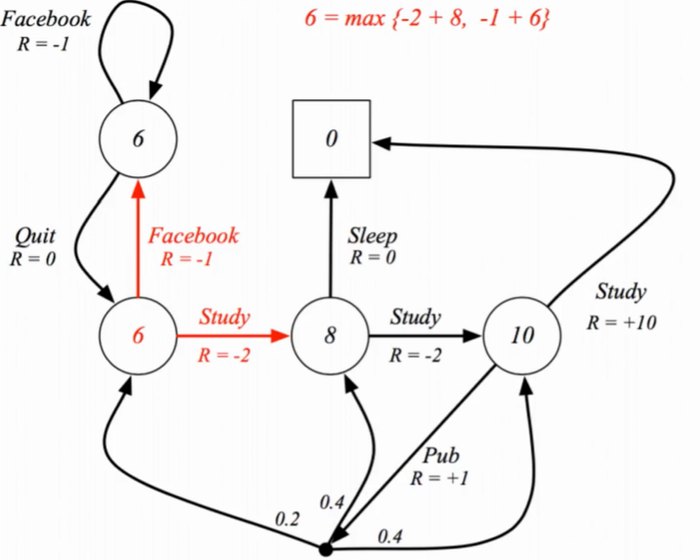

algorithm of MDPs

model-free RL = agent observes everything

planning = agent knows everything

A model of the environment is known

The agent performs computations with its model (without any

external interaction)

The agent improves its policy

a.k.a. deliberation, reasoning, introspection, pondering,

thought, search

Reinforcement Learning:

The environment is initially unknown

The agent interacts with the environment

The agent improves its policy

Model of MDPs predicts what environment it will do next

P predicts next state, R predicts next reward

Iterative Policy Evaluation

for each iteration:

v = immediate reward + sum of all P(s’)*v(s’)

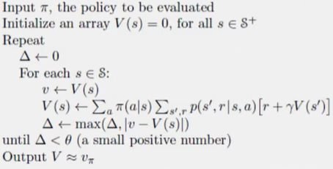

Ex. gray square is the terminal state. r = -1 means we want to reach terminal state ASAP

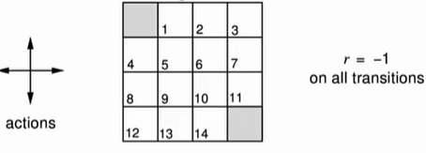

uniform random policy (same probability)

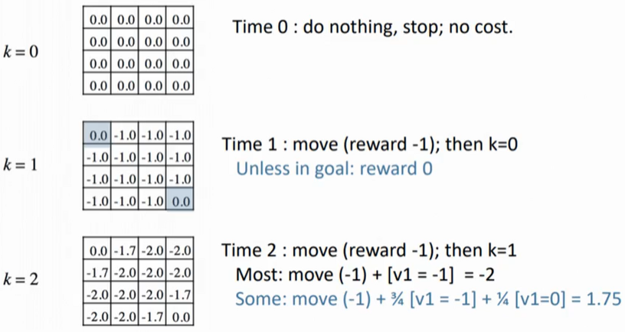

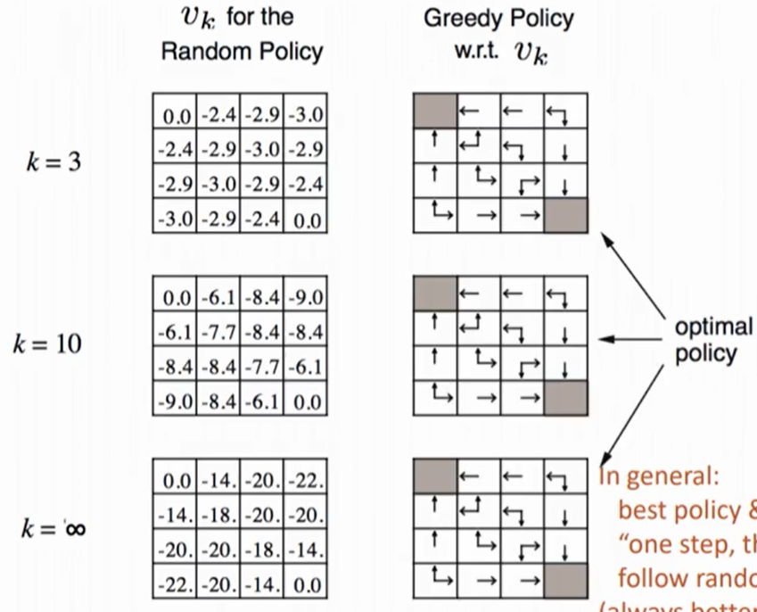

Value Iteration coverage if discount < 1 (even without going to terminal state, can converge)

Find the optimal policy (policy iteration)

evaluate the policy with v_pi (s)

improve it with greedy(v_pi) = choose the one with max v_pi

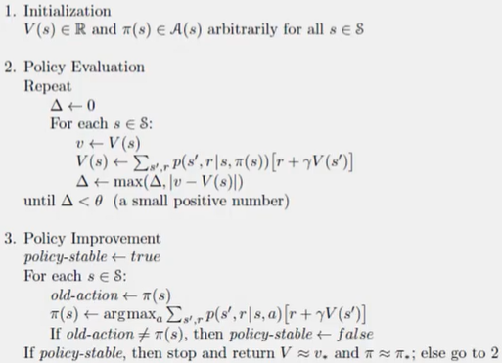

Value iteration via Bellman optimality

among all possible actions, compute value of each action and pick the best one

no policy needed

Problem vs Bellman Equation & Algorithm used

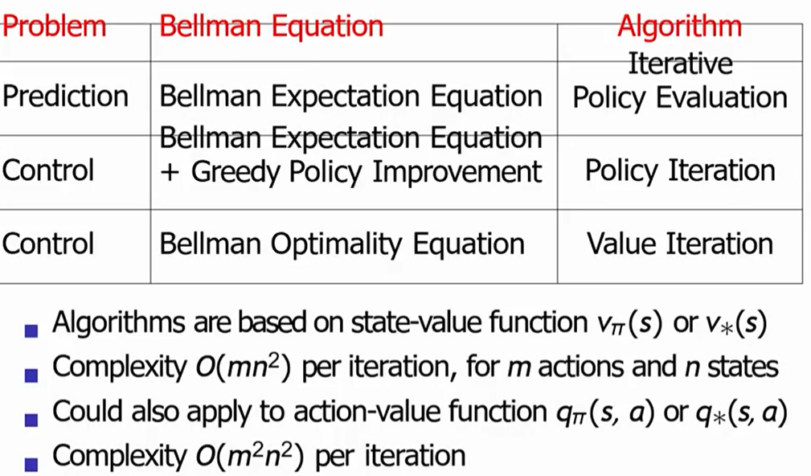

Monte Carlo Learning

MDP unknown and evaluate policy pi

sampling

complete episodes (end at the terminal state)

Temporal Difference Learning

NO Logic & Reinforcement Learning, Neural Networks in Final

YES decision tree, search, game, constraints faction , probability, basic ML,